Lindores Litanies 14th Jan. 2021

*The Newsletter of*

*Lindores Parish Churches of*

*Newburgh and Abdie & Dunbog*

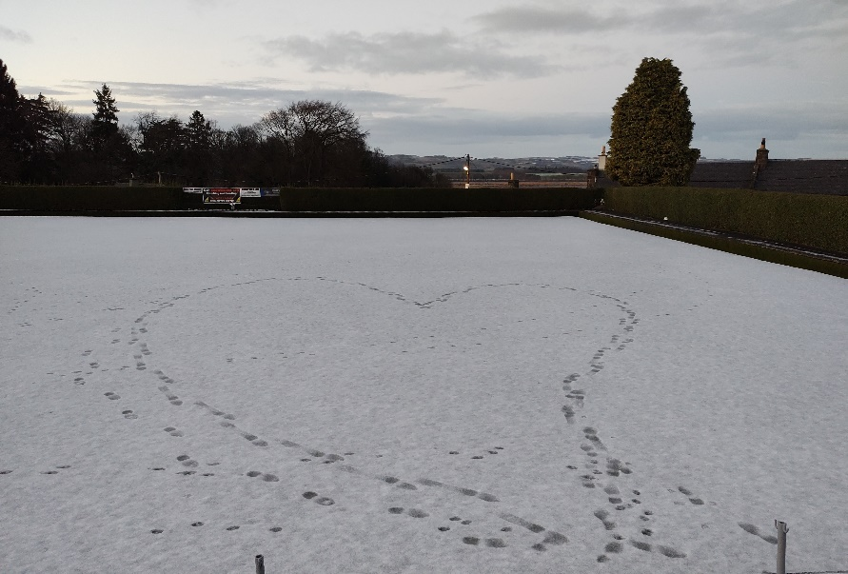

**Happy New Year!**

The first few days of 2021 hasseen an increase in virus numbers, more restrictions on our activities and enough snow and ice to make venturing outside a daunting challenge for many.

But the wonderful spirit of our community lives on. The heart shaped footprints in the snow-covered bowling green, the kindness of an electricity company to some local pensioners and the joy expressed by so many about our scarecrow nativity scene are some of many signs of hope as we wait for the promised vaccine and the coming of Spring.

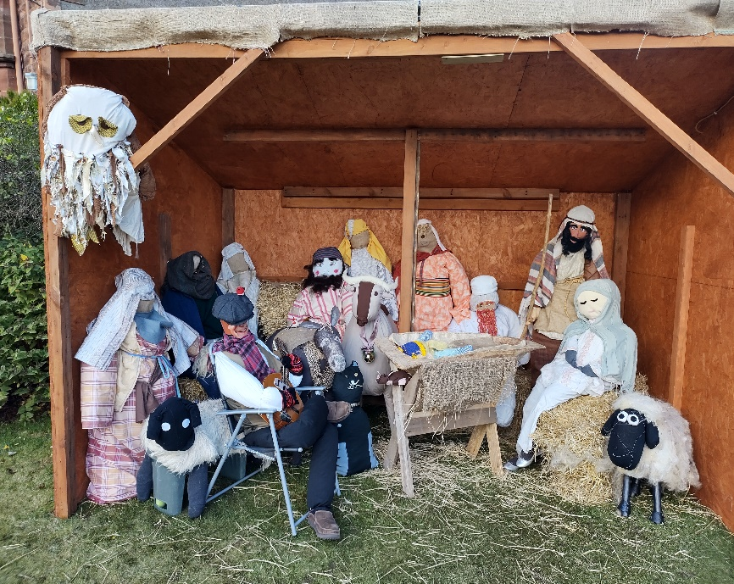The recently vacated nativity stable has been left in place for future community displays beginning with a celebration of love & friendship on February 14th. Any contributions of home made friendship rings or hearts (1-2 feet diameter) will be gratefully received.

**Angels from the realms of Newburgh**

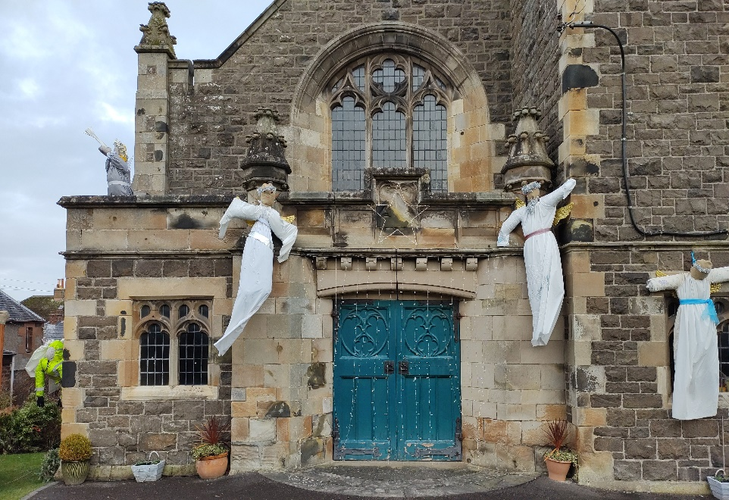There was a wonderful variety of angels displayed round Newburgh church this Christmas. The heraldic angel, beautifully floodlit on the parapet, gave a sense of glory and gravitas whilst the local hero angel in the high vis jacket, suspended between church and stable, prompted a storm of enquiries on Facebook about what manner of creature this might be.

Last week angelic activity was reported by some senior residents in Mugdrum Place after a faulty cable on Hill Road caused a series of local power cuts. On one of the coldest days this winter residents were dismayed to be informed that repair works would begin at 9am the following morning, leaving them without electricity for several hours.

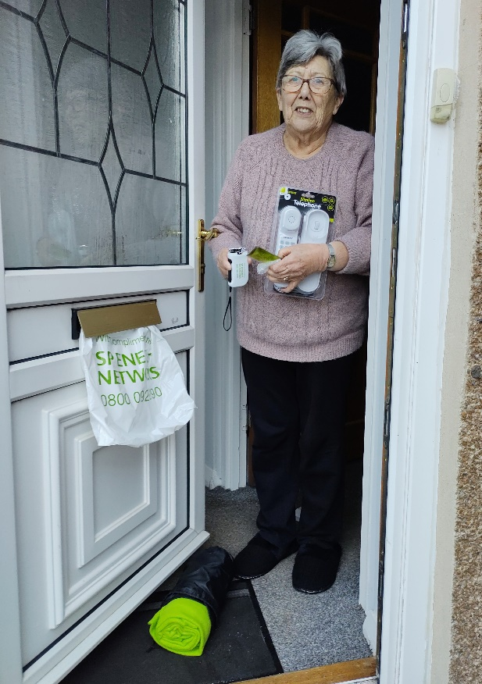Having got up early to boil water for her flask, Elaine Cluny was surprised by a knock on her door before 9am. A workman gave her a bag containing a bright green blanket, a torch, a hand warmer and a phone to plug into the telephone socket in case she needed help. A similar package was delivered to all the other pensioners on the street.

Elaine feels that SP Energy provided an outstanding service to the elderly and wants to thank them for giving them warmth and light on a cold day.

**Better Connected**

Thanks to recent efforts by family and friends I now have a super smart mobile phone, an Alexa echo dot and a fire stick, which somehow manage to communicate more easily with each other than with me!

Although my enthusiasm for new gadgets and updated technology has waned over the years (my ponderous efforts with new devices is a source of great amusement to my children) I do try to give things a go when needed.

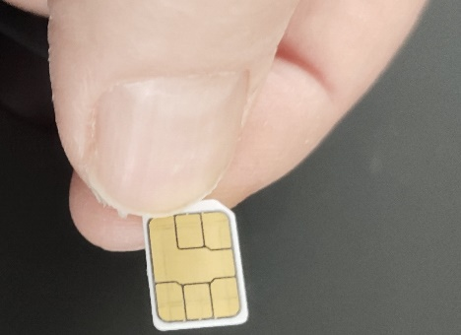So, when my daughter sent me a SIM card for my new smartphone, I bravely agreed fit it myself. I followed the instructions carefully, selected the right size (nano not micro or standard) and with the help of a small metal prong, a bright light and a pair of tweezers, carefully inserted it, closed the compartment and triumphantly switched on the phone: The display read *No Service.*

Frantic reading of the SIM packaging small print informed me it could be up to 24 hours before my new SIM was activated. I considered putting the old one back in again, but once was quite enough excitement for the day. Surely I could manage without calls or text messages for a while…I still had a land line…but the feeling of being less connected than usual made me feel strangely unsettled…like I’d lost something important.

Perhaps that’s symptomatic of the sense of loss and disconnection so many of us are experiencing just now. The fear of illness, tightening restrictions and the closure of our churches has left many of us feeling less connected to each other and more unsettled in ourselves.

It’s perhaps a good time to remember that our Creator has other ways of reaching us, regardless of *No Services* in church. Psalm 48 verse 10 encourages us to *Be still and know that I am God.* Being still is a good way to calm ourselves and gain access to the source of peace and love that bubbles deep within. But it’s not always easy to reach that state of deep stillness, especially when the mind wants to be active, so here’s a couple of things I find useful.

**Experiencing nature** is recognised as a way to calm ourselves and to improve mental health and wellbeing. Even when it’s not possible to get outside, especially in wintry conditions, the act of sitting and looking at pictures of nature can be just as effective. Spending time contemplating a woodland scene, a bird feeding table, or whatever aspect of nature you feel able to lose yourself in, can help us feel more peaceful and better able to connect with life in all its fullness

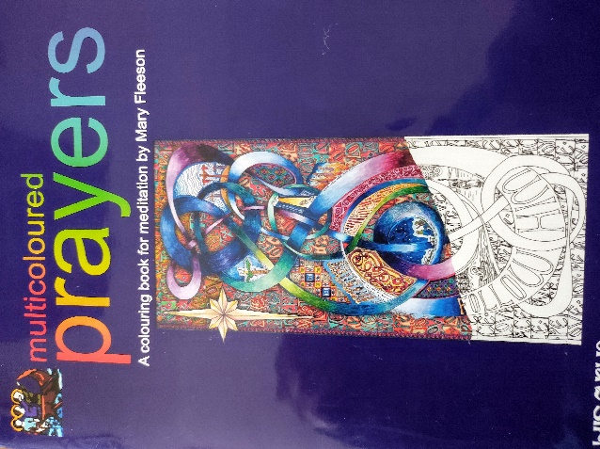 **Multicoloured Prayers** are another way to still my mind, involving felt tip pens or crayons and words from scripture. I’m not a great artist but it’s lovely to lose myself in the colours and shapes of different words and prayers.

I use this book of multicoloured prayers by Mary Fleeson from Lindisfarne Scriptorium. These, and others like them are available to buy online.

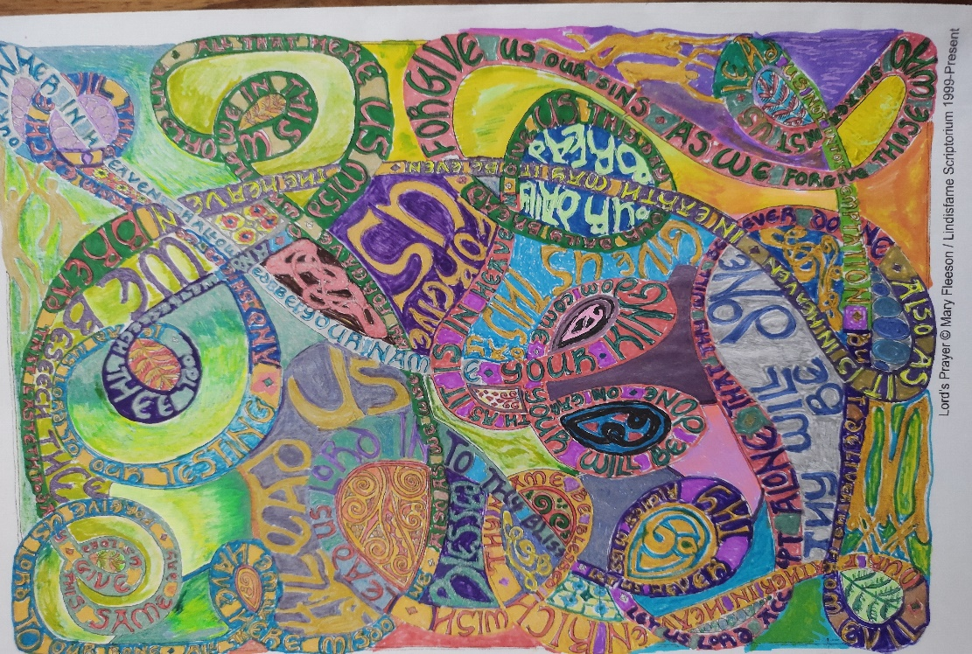

Here’s a coloured-in version of the Lord’s prayer I did from Mary Fleeson’s book.

Maybe others have found ways of being deeply still that you might like to share in our newsletter?

Whilst the wonders of technology continue to amaze me - my Alexa dot can make my smartphone ring when I lose it in the house – there are far greater wonders within and around us. Perhaps this is the year we’ll learn to listen better to that still small voice of calm and know how closely connected our God is to us.

**Answers to last month’s Seasonal Quiz from Kathleen Black**

|  |  |
| --- | --- |
| ***Illuminations for little people? (5,6)*** | ***Fairy lights*** |
| ***Was she an army mother? (4)*** | ***Mary*** |
| ***Spruce, fir, etc (9,4)*** | ***Christmas tree*** |
| ***Does she sing Christmas songs? (5)*** | ***Carol*** |
| ***Holly’s pal (3)*** | ***Ivy*** |
| ***Odd tables in Jesus’ birthplace? (6)*** | ***Stable*** |
| ***A gift without a vowel (5)*** | ***Myrrh*** |
| ***Oh no it’s not a traditional Christmas show! (9)*** | ***Pantomime*** |
| ***Kiss under this parasite (9)*** | ***Mistletoe*** |
| ***Are you likely to gobble this at Christmas? (6)*** | ***Turkey*** |
| ***Is this a well behaved child on top of the tree?(5)*** | ***Angel*** |
| ***Listen to the sparkling Christmas decoration (6)*** | ***Tinsel*** |
| ***Jesus’ first bed – of German extraction? (6)*** | ***Manger*** |
| ***Do the law scenes make a good king? ((9)*** | ***Wenceslas*** |



A wee reminder about the peculiarities of our language from a friend who teaches English to French students. She assures me it’s nothing to do with Brexit!

**Online Sunday Worship**

Sunday 17thJanuary 10.30am: Our own Songs of Praise (Lindores Zoom)

Sunday 24th January 10.30am with Rev Susan Thorburn (Lindores Zoom)

Sunday 31st January Joint service with Rev Alan McGougan & URC church (details tbc)

Link for Lindores Parish services on Zoom <https://us02web.zoom.us/j/8652623623?pwd=R05HQmRsQk12bWs3d1FmMElmeVZNQT09>

Meeting ID: 865 262 3623

Passcode: Lindores

People are welcome to join zoom by phone or without video. Please contact Valerie if you want any information about our zoom services or meetings.

**Services available on National TV and radio**

BBC One Scotland: *Reflections at the Quay* 17th January at 1130

BBC One: *Songs of Praise* 17th January at 1315

BBC Two: *Songs of Praise* 24th January at 1315

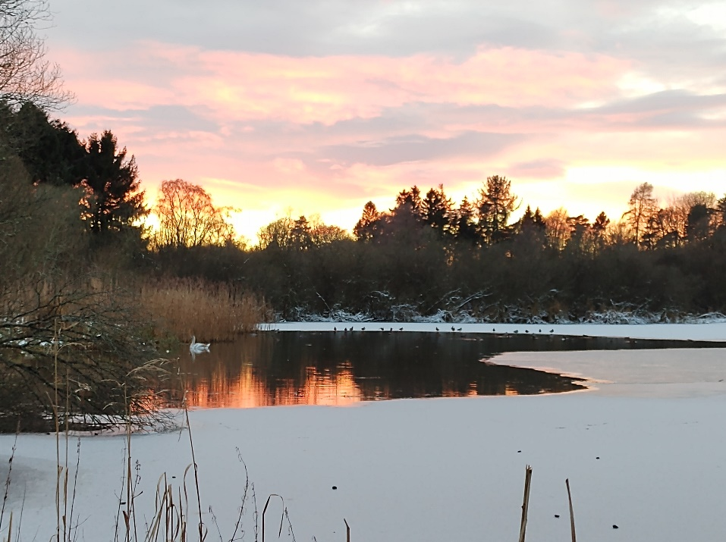BBC Radio 4: *Sunday worship* every Sunday at 0810

BBC Scotland: *New Every Sunday* every Sunday at 0730

**Valerie’s contact details:**

[**revalerian@gmail.com**](mailto:revalerian@gmail.com) **Phone 01337 842799 mobile 07720 327766**