Lindores Litanies 29th Aug 2020

*The Newsletter of*

*Lindores Parish Churches of*

*Newburgh and Abdie & Dunbog*

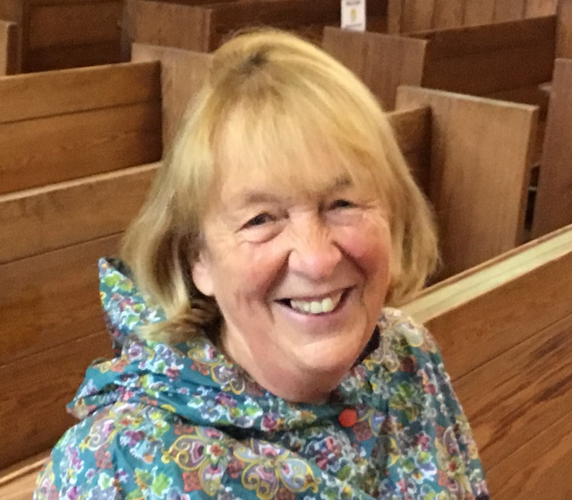

**Change of Interim Moderator**

On September 1st Catherine Wilson replaces Bill Hunter as our Interim Moderator in Lindores Parish. Here’s a few words from them both:

In early February this year – doesn’t that seem a long, long time ago – as I was driving away from Abdie and Dunbog, having joined you for Sunday morning worship, for lunch and for a session in which Rev Jeff Martin read to the assembled company the final draft of the report on the Interim Review process (a required element when a church is in Guardianship), I thought “I shall be rather sad not to be coming back here.” This was a passing thought, but it actually said a lot. My visits to Lindores in the preceding months had numbered only three, but they had made a big impression on me. The welcome the review team had experienced had been warm, even though to you it must have seemed that we were there to ‘inspect’. What we then went on to discover, through informal group discussions, was that ‘heart-warming’ was a good descriptor’ for all that you were aiming to do – and still are. What was particularly clear was that you are making every effort to reach out into the community and that ‘the community’ was responding with enthusiasm.

When I was asked if I would move from being Interim Moderator at Largoward to follow on from Bill, how could I refuse given all that I had said in Presbytery circles about your worship and work?

I am sad to be leaving Largoward Church and its lovely congregation from whom I had learnt a lot about life in a small rural community, but I am looking forward to being your Interim Moderator and sharing with you and Valerie in the challenges - and the successes - that lie ahead. I admit to being somewhat apprehensive being something of a novice and not an ordained minister, and Bill’s are big shoes to try to fill – metaphorically speaking. However, I am willing to commit time and with God’s assured help I hope to offer more. To use the words of a hymn which I always find helpful in such circumstances

*Father, I place into Your hands, The things I cannot do….…For I know I always can trust you*

Catherine

 It surprised me on looking back that I have been “Interim” Moderator since 2016! Where did the time go? I volunteered my services as your Interim Moderator because of the Cluster connection and because we were all looking at the future for our churches together. It made sense to me to “keep it in the family” so to speak. I still think that was right.

However, Presbytery has asked me to move on to be Interim Moderator at Ceres, Kemback and Springfield. In some ways a simpler task as they have been given permission to call, so there is an end envisaged. That’s been complicated by Covid-19 and all of us are trying to get our heads round how you search for a new minister under these conditions.

I have greatly enjoyed being with you over these past few years and getting to know people in Lindores. Even just that new name is something that speaks to me of the great transition that has gone on in this time. I came to the linked charges of Abdie & Dunbog with Newburgh and now we are one. I have been greatly heartened and encouraged by the way you have become one fellowship and the care and inspiration you give to each other. It has really been a growing of the church by bringing the strengths of each into the mix.

It’s also been a joy to work with Valerie who has so much enthusiasm for this church of people and who brims full of exciting ideas. I know as you move on together you will journey into more beautiful things for God.

Bill

**Holiday Pastoral Cover**

Valerie is taking holiday with family in deepest Yorkshire from August 29th to September 12th. If anyone needs pastoral support during that time please contact Catherine Wilson (01333 310936) during the first week & Bill Hunter (01337 832717) from September 5th.

**Elizabeth Pearson is asking people to save empty shoe boxes for our Parish contribution to the Blythswood Shoe Box Appeal 2020. Drop off points will be available in both churches when our buildings re-open**

**Church re-opening**

Session are meeting via Zoom on September 1st to confirm plans for re-opening church later that month, details of which will follow in the next newsletter.

**Valerie’s email:** revalerian@gmail.com

**Open Gardens though a different lens: Newburgh 2020**

The annual Open Gardens Day in Newburgh provides a wonderful opportunity to walk around town enjoying a variety of different gardens and discussing them with others over an excellent array of home baking and beverages, in churches at either end of the High Street. Judith Laughlan, one of the organisers of this highly successful event, has provided us with some photos and comments from previous participants, so we can enjoy their wonderful gardens again, albeit through a different lens.

*Sadly we have not been able to participate in Open Gardens Scheme this year because of the restrictions. Those of us who are fortunate enough to have a garden and who love gardening have spent lockdown getting out of the house and even in a relatively small space we can grow our own fruit and vegetables. Fortunately those who are not gardeners can still enjoy some of the benefits by visiting others. Gardens are here to be shared. What a wonderful way to spend an afternoon out in the fresh air in the serenity of a garden. So here's to next year when we hope to open our gardens again and support our local community.*  *Judith*

**Judith’s garden**

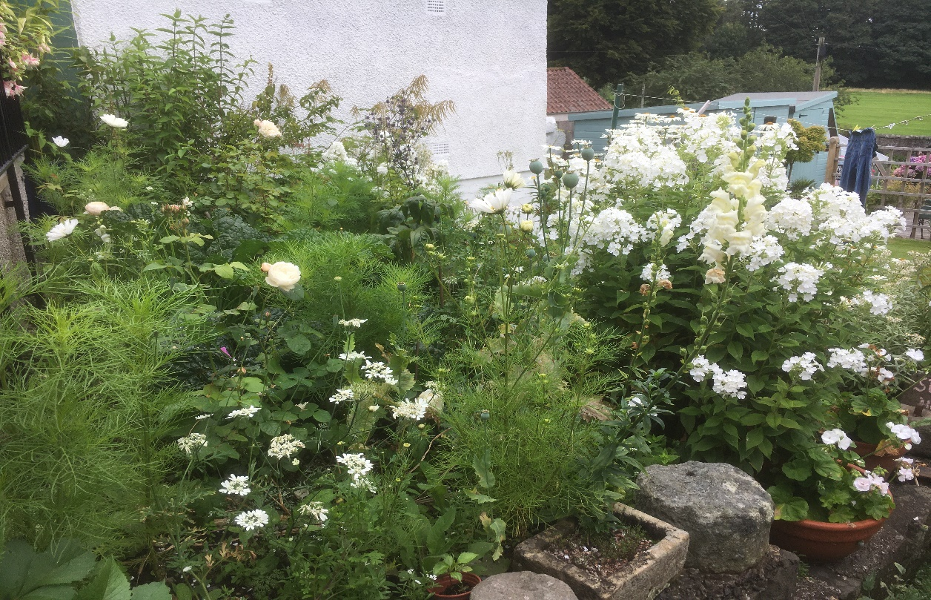

I have been trying to create a white garden during lockdown as i think there is something beautiful about a white garden. It has a freshness and purity that is difficult to achieve with other colours and there is no risk of clashing.

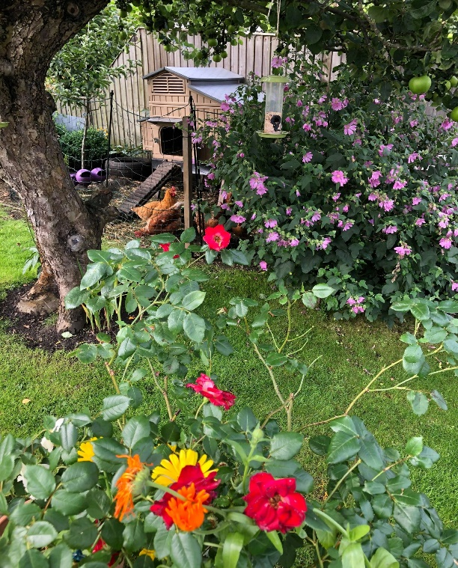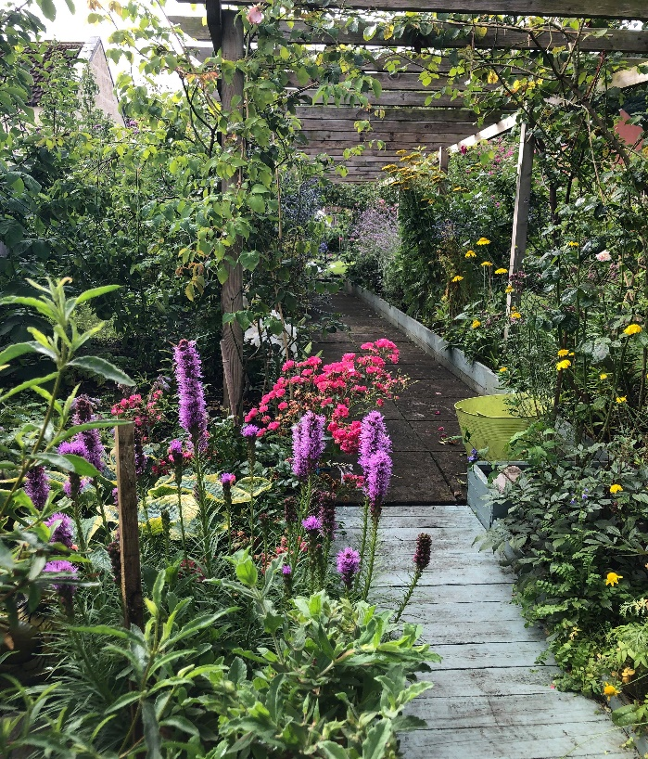 **Jenny and Martin’s garden**Hidden away above Newburgh high street, Jenny and Martin move about their hidden garden with a to-do list hanging up on a mossy wall. Whether it's pruning herbaceous borders, plucking juicy plums from the heavily laden branches of their three trees or feeding the six sturdy chickens that roam around, there is always something to do. 'I love it', Jenny says, 'It keeps me very busy but I love every minute of it. Watching the bees on the lavender and the butterflies flitting among the flowers is wonderful to watch.'

There are too many species to name but the 7-foot lilies, sunflowers, dahlias, hostas and agapanthus form just a part of the polychromatic horticultural wonderland of this snug, urban green space. 'I love making this place my own, adding a plant here or thinning another there, there are so many ways to add a personal touch to a garden. I can express myself freely when I spend time here', continues Jenny.

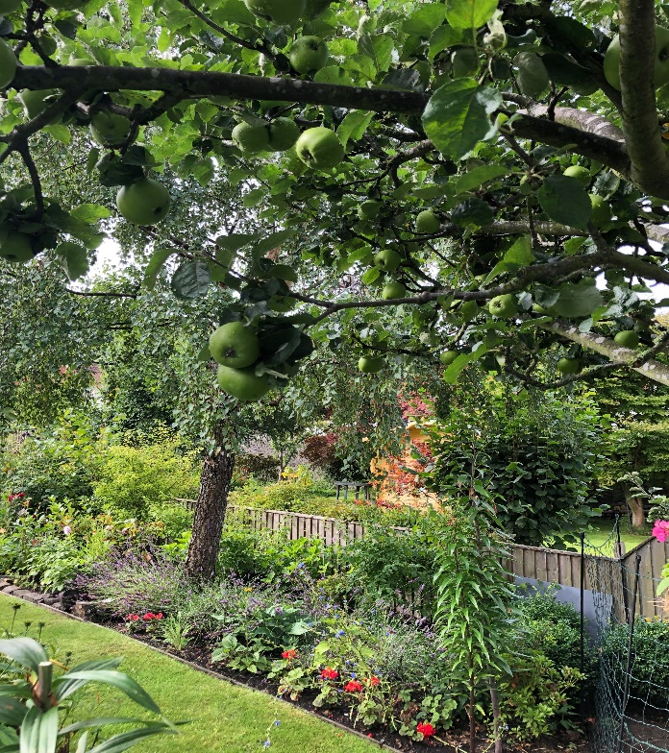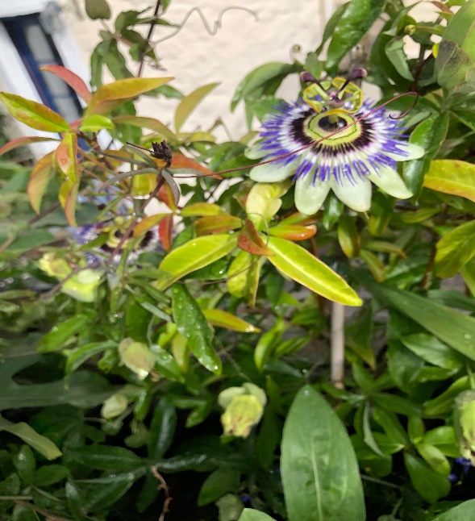Apples, pears, blueberries, raspberries and strawberries among others make the garden a fruitful place and the potatoes, carrots and greens make eating a healthy, balanced diet using all organic foods and a minimal carbon footprint a simple task. The fresh eggs laid daily by the hens help things along too.

'We love our garden. It's a big part of our lives', say Martin & Jenny as they don their gardening gear, feel the afternoon sunshine on their faces and prepare to tick an item off their ever changing, but always enjoyable to-do list.

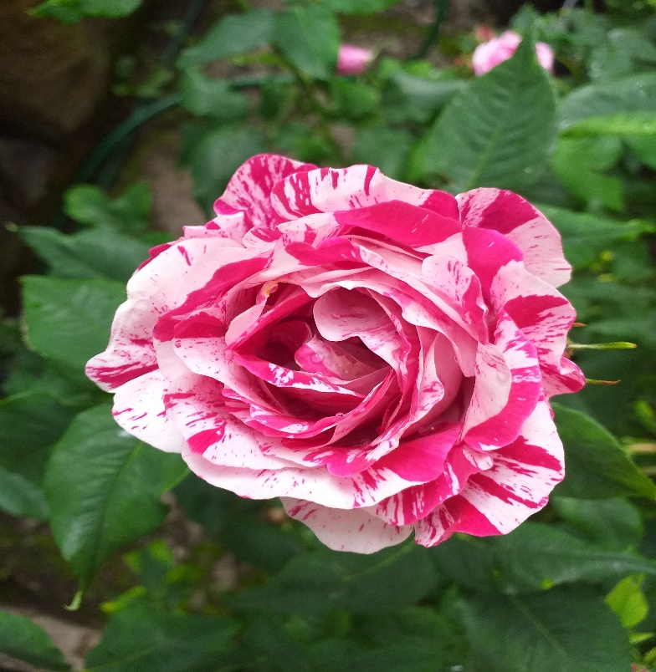**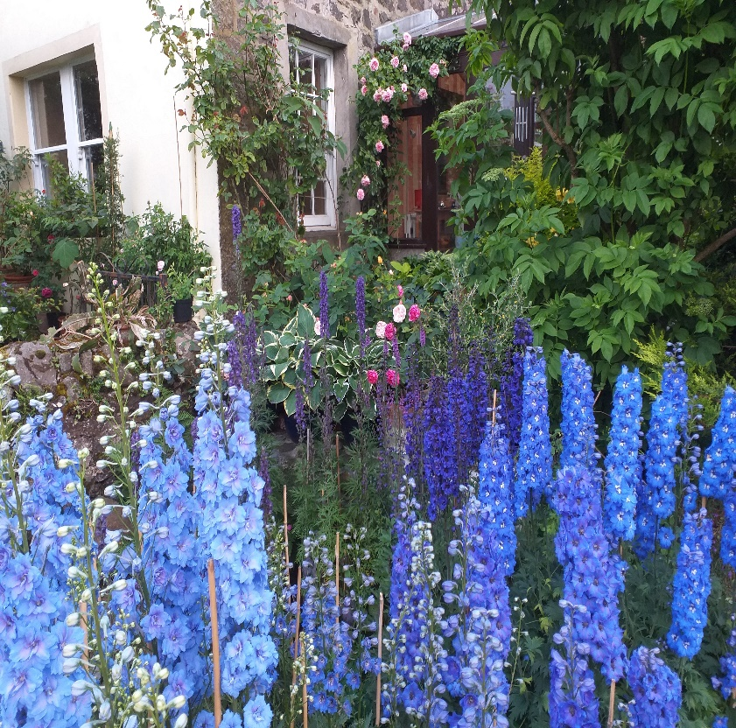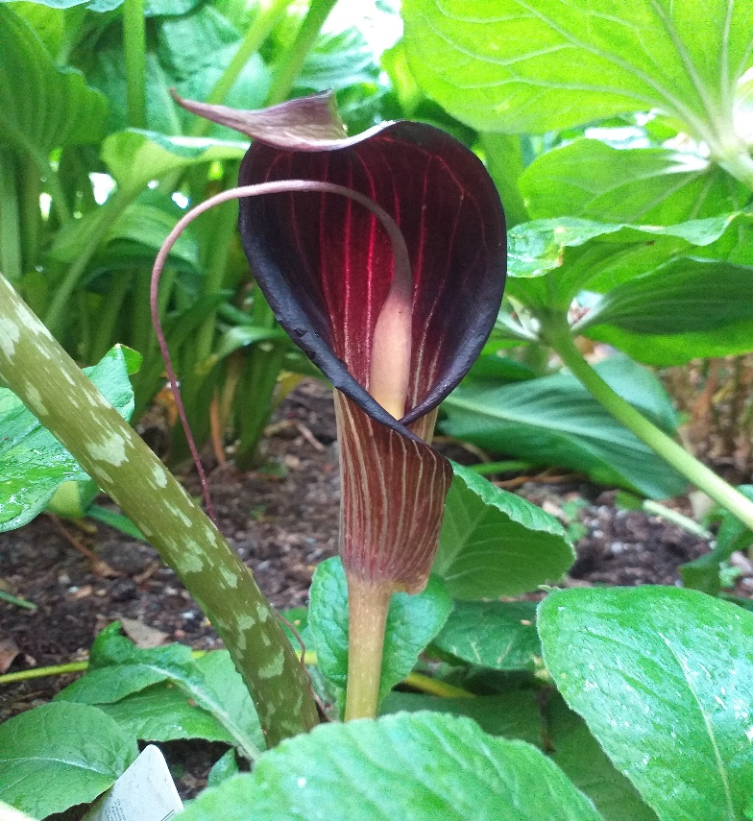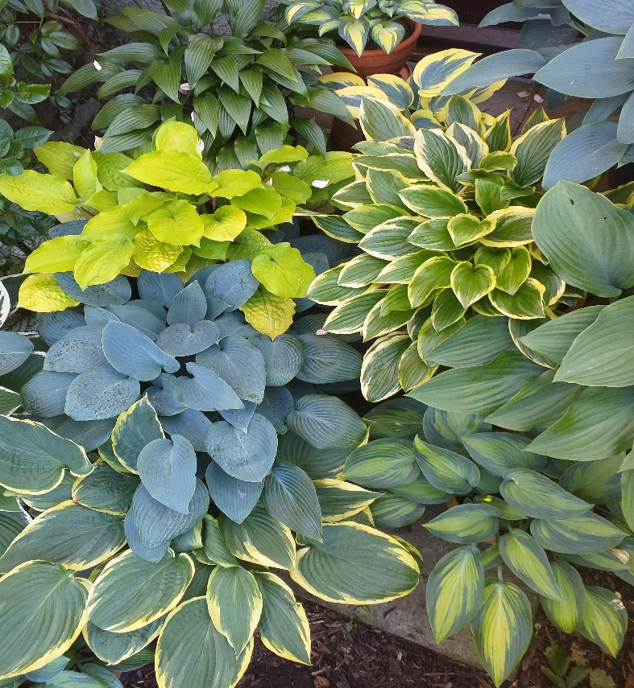Adrian’s Garden**

Ferdinand Pichard rose Hyprid perpetual - stands up pretty well to the rain and has a beautiful scent - many of my roses are grown in pots due to lack of space and the golden rule here is to feed the plant not the soil as it becomes exhausted very quickly - nice way to grow some of the larger varieties as they are restricted and miniaturised - ramblers on wigwams can be done this way easily.

A view of the delphinium patch - all grown from seed (Larkspur nurseries) - plants now into 4th year.  The blues really are truest blue and this year they were well staked for the wind and rain - dead easy - watch for slugs at the start and feed heavily with organic material.

A few of my hostas - all in pots amongst them are ‘June’, “Fire Island’ and ‘Halcyon’ - dead easy in pots.

Arisaema - ideal for a shady, damp, woodland garden - many varieties available and often called Cobra lilies through their shape - large decorative leaves as well

**Clare and Gordon’s garden** (not the one in Newburgh!)

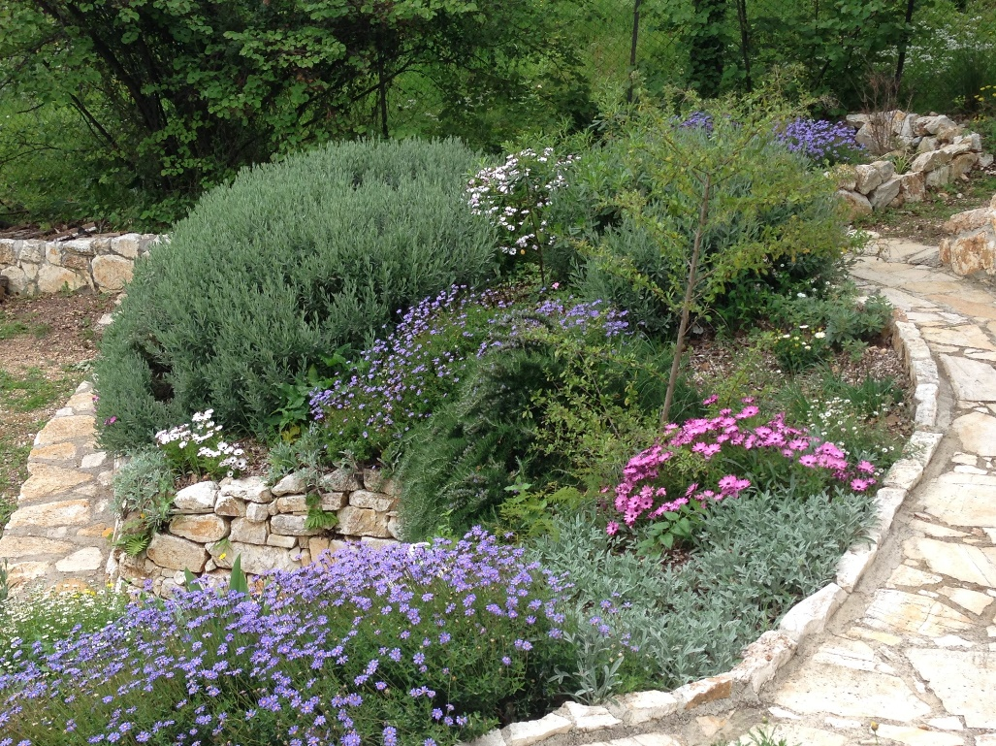We started to make a garden around our house on the island of Corfu about six years ago. It was a very steep learning curve for someone who, until then, had only gardened in Scotland! The site is steep, south facing and looks over the Ionian Sea towards the Albanian mountains. The sloping ground has been terraced in past times and planted with olive trees, most of which we have left in situ and the ground underneath is covered with grass and wild flowers. In the middle of summer this is dried brown, but in winter, spring and autumn it is a delight of grasses and naturally occurring flowers and bulbs. The show begins in January with tiny iris reticulata, cranesbill and cyclamen.

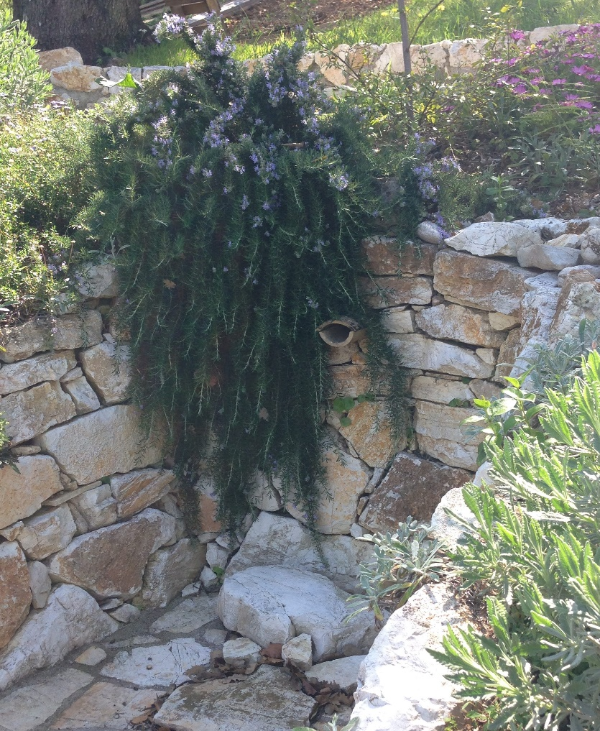There are mediterranean climate conditions in five regions of the world, not just around the Mediterranean Sea, their main feature being hot, dry summers and mild, wet winters. Our lowest temperature on Corfu is about 6°C, rising to 38° -40°C in July and August. The weather can be quite windy as it is a small island and in the winter the cold wind is a problem to some tender plants. In June, July and August there is virtually no rain at all, (4mm) only the occasional thunder storm, but in January, and then from October to December there can be 250mm of rainfall. Quite extreme conditions!

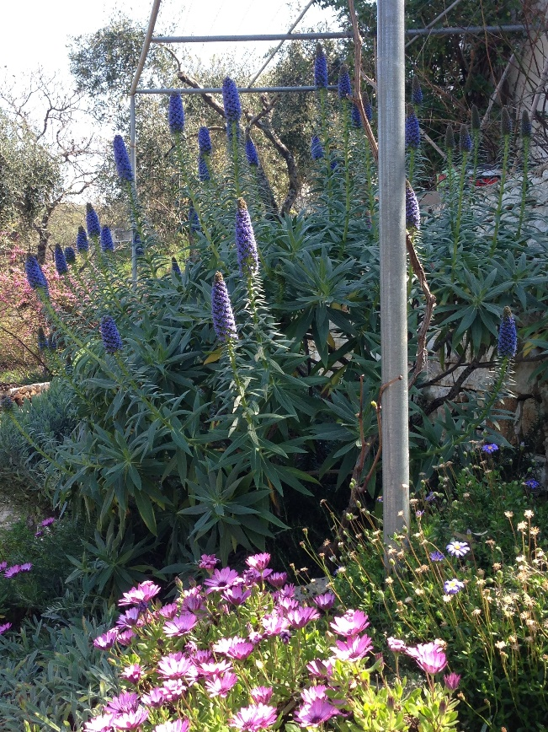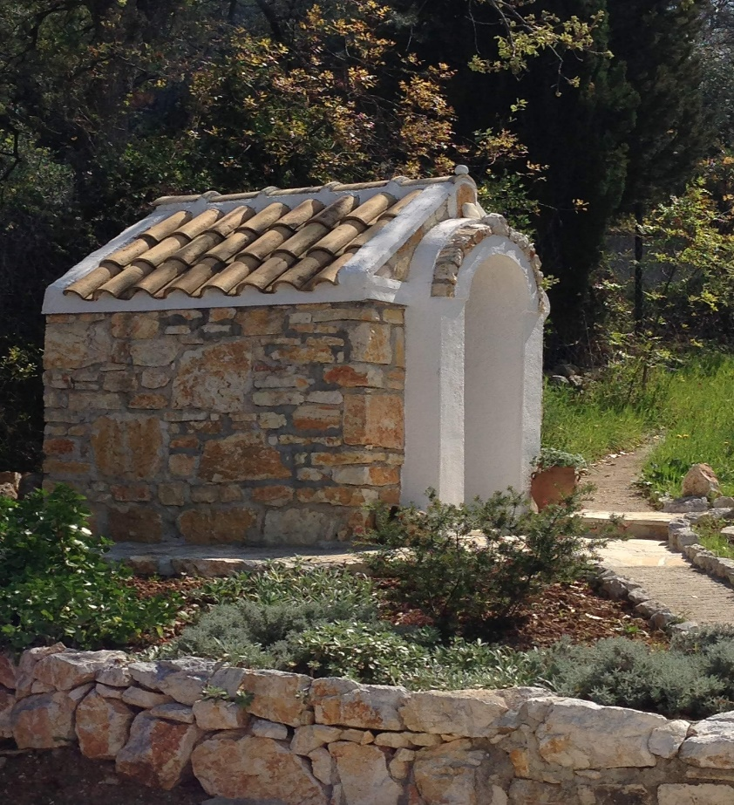We have planted what is commonly called a “water wise” garden, mostly in raised beds built of local stone, around the house, leaving the rest of the land wild. Plants are only watered a lot when they are establishing, after that they are only watered once a week in the hottest three months and not at all for the rest of the year. Because of this the planting is made up of drought tolerant flowers and shrubs which thrive in the local conditions and don’t need too much attention. I have tried to plant a variety of things so there is interest and colour in the garden all year round, and I’ve mostly succeeded, the leanest time being July and August. Then the shrubs, many of which are closely clipped, come into their own, giving interest with their shapes and various shades of green and grey. Gordon has built lots of paths, steps and walls, a water feature and even a tiny chapel! (“Ecclesiataki” in Greek.) It’s dedicated to St. Andrew, of course!

It is a beautiful garden to work in with views of the olive clad hillsides on three sides from our neighbour's olive groves and vegetable gardens, complete with a donkey or two, chickens, dogs and cats. Behind the house the land rises steeply up towards the summit of the only mountain on Corfu, Pantokrator. There are pine martens, olive rats, owls and tortoises, not to mention an array of large, sometimes scary insects and lovely colourful butterflies. To the south we can see the flat land leading down to the sand dunes and a three mile beach, the sparkling sea and the Albanian coast opposite with mountains, snow topped in the winter months. My husband loves to watch the birds, most especially the bee eaters, hoopoes and golden orioles which pass through on their way to other continents. Sometimes I feel the plants take second place!