Lindores Litanies 19th July 2020

*The Newsletter of*

*Lindores Parish Churches of*

*Newburgh and Abdie & Dunbog*

**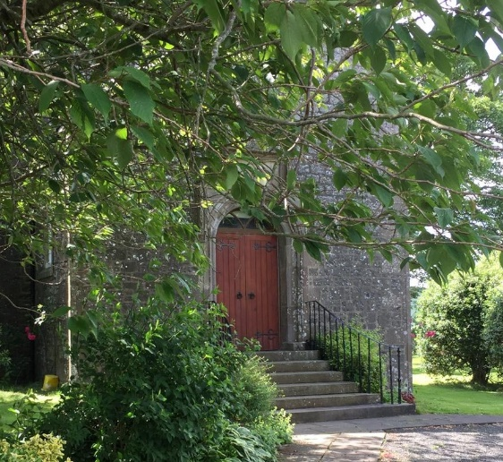***When can we have Sunday services again?* Lots of folk have been asking me that recently, echoing our heartfelt longing to gather back in our beloved church buildings. It will be wonderful to open the doors for Sunday worship again but there’s lots of procedures and practicalities to think about first. It is vital that we keep each other safe by minimizing the risks of meeting as a congregation.

This time of waiting reminds me of Psalm 13, which begins *How long O Lord, How Long?* Our Kirk Session plan to discuss these issues on August 10th; hopefully a date will be suggested then.

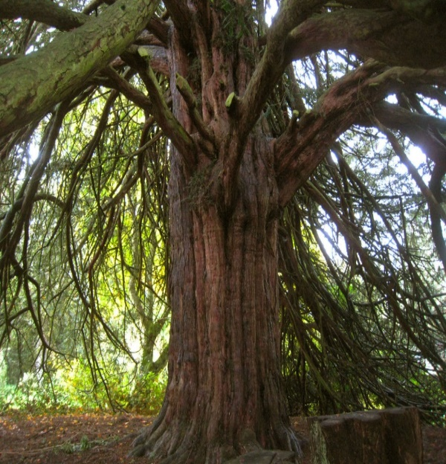Having carefully measured the pews in both churches I estimate we will be able to accommodate all of our regular congregation, although social distancing rules mean people might be in parts of the church they’ve not sat in before. Singing hymns is now prohibited in church so we’re exploring other elements of worship from dialogue to drama, humming to drumming and beyond! Maybe you could reflect on what matters to you in worship? What helps you engage with the Spirit of wholeness and holiness who draws us closer to the Divine and helps us love each other better? I would greatly value your thoughts.

Valerie

**Walking a Labyrinth**

Labyrinths are ancient, pre-Christian devices, used to enhance meditation. They are not the same as mazes, in which you easily get lost; in a labyrinth there is only one route to follow, which via a circuitous route takes you into the middle and then back out again. There are no walls or hedges as the pattern is marked on the ground in two dimensions only. There is nothing confusing about the directions to take. All you must do is keep putting one foot in front of the other.

So, what’s all the fuss about? Why should anyone bother? What’s it for? A walk round a labyrinth is probably different for everyone, but here’s what it has meant to me:

1. 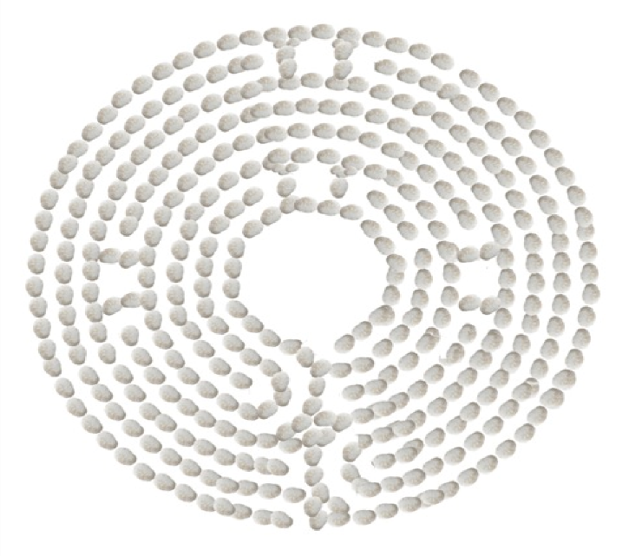Most of us live in a world where we have to make choices all the time and it can be exhausting. Psychologists have carried out repeated research studies which show how too much choice can impact your mental health. But the labyrinth sets us free from this. Just follow and see how it feels. Relax and enjoy.
2. As you follow the path, you will find yourself going in what seems like completely the wrong direction. Oh dear! Is anyone watching? What a waste of time! But if you just keep following the path, as you know you must, you turn a corner and it begins to look a little more promising. Not necessarily direct, but possibly more likely to turn out well. Ouch, until you take the next bend. Does this remind you of anything?

Real life, for instance?

1. There may be other people on the path. In the gloomy words of the philosopher Jean-Paul Sartre, Hell is other people! They’re going too fast, or too slow, or getting in your way! What’s the overtaking etiquette, you ask yourself? Maybe you see someone else hovering on the edge, watching you and wondering if it’s safe to join. Part of you wants to wave and smile - ‘come on in, the water’s lovely!’ but then you realise they'll find out anyway, just as you have, and you don’t want to speak because the silence feels very peaceful.
2. If like me your balance is dodgy, you might worry about falling. You wish you had brought a stick. But in the meantime you just have to concentrate. Or you could go full pilgrim, on your hands and knees. As Anne Begg, the first disabled MP at Westminster, came to realise – it doesn’t matter how you get there, so long as you arrive.
3. 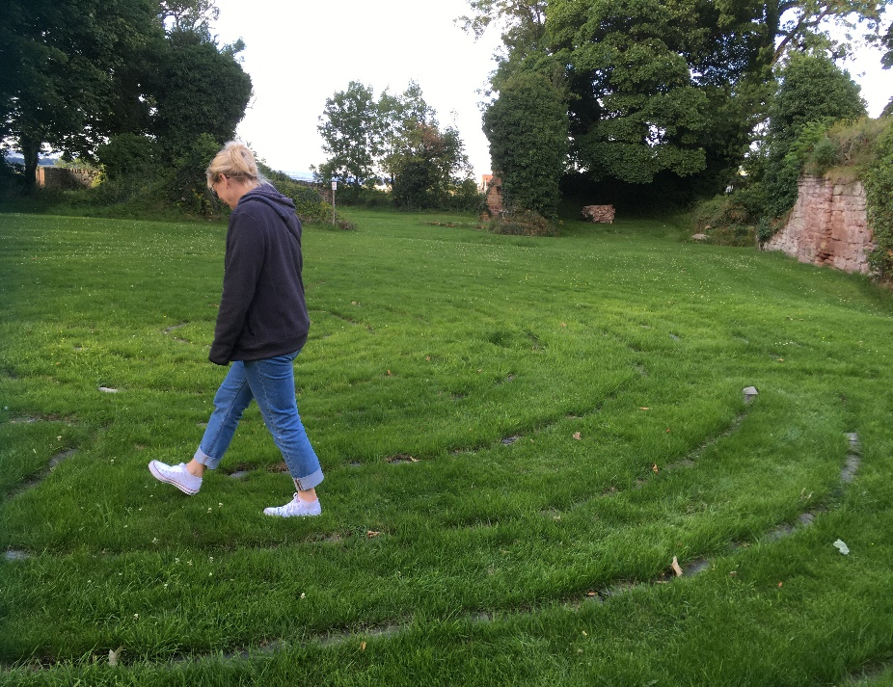And what of the view from the centre? Does it thrill you? Or maybe just give you a satisfying sense of completion? You might find that the arrival isn’t any more significant than the journey. That’s interesting.
4. On the way back, you think you know what to expect. You can remember that this meandering around is just the way it is, in labyrinths as in life. And because you’re less anxious about it, you can pause and enjoy the view. There’s no hurry.

My first experience of walking a labyrinth was at the Episcopal Church in Dollar, where members of the congregation built a double-circle labyrinth to fit among the trees in the church grounds. I didn't really know what to expect, other than comments from friends that walking the labyrinth could be quite a spiritual experience. Well, I'm open to spiritual experiences, despite my prosaic mind, and my experience was certainly enjoyable. It gave me some insights, and I found a certain humour in it.

If you Google You-Tubes with 'what is a labyrinth’, you will find many enlightening and enjoyable videos – some learned, some experimental, and no doubt one which makes sense to you. I particularly enjoyed the ones which demonstrated how to draw a labyrinth –it was even trickier than walking one.

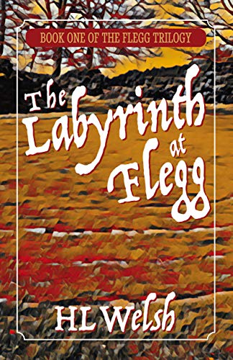My recently-published first novel was partly inspired by our own Lindores labyrinth. Having listened to Valerie's obsession for many years, it was wonderful to see her bring this project to reality. Unexpectedly, this labyrinth took me in my imagination to a meeting between characters from the present day and the 16th century, just after the monks were banished and the Abbey destroyed. I wanted to fictionalise my setting, and renamed our little town 'Flegg’, after the Dundonian word for fright or surprise; hopefully giving a mysterious edge to what I was trying to achieve. If you like historical fiction with a little fantasy edge, and spot or two of romance, you might like to read it; it’s available on my website <https://www.hlwelsh.co.uk> or ask Valerie.

So there you go: walk the labyrinth and be ready for surprises!

*Helen Welsh, Author*

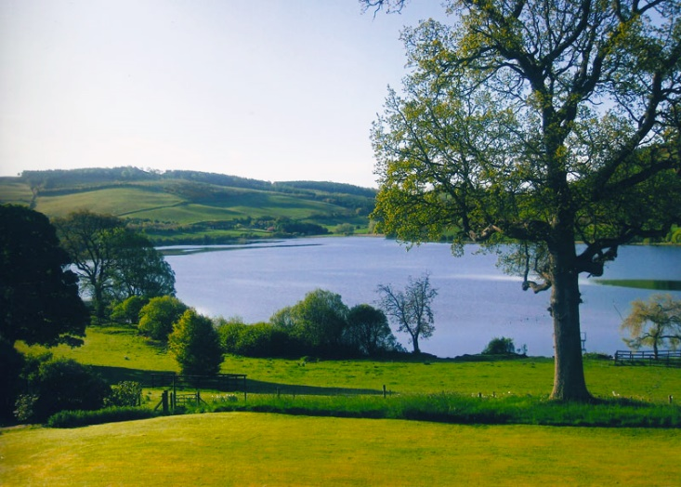**Open Gardens at Lindores House**   
(KY14 6JD)

**Sunday August 2nd & August 16th, 1-5pm**

Entry £5 (proceeds to N.E. Fife Scout Group, Newburgh)

No refreshments provided but visitors welcome to bring own picnics and rugs/chairs

**Answers to Herb Quiz (5th July)** 1--Thyme: 2-Rosemary: 3-Dill: 4-Parsley: 5-Sage: 6-Basil: 7-Sweet Cicely: 8-Bayleaf: 9-Mint: 10-Chives: 11-Bay: 12-Borage

Request from our Treasurer

if you are saving up collection envelopes for church Please could you make your donation by cheque or standing order instead of cash. this for both safety and convenience. thank you

**Births:**

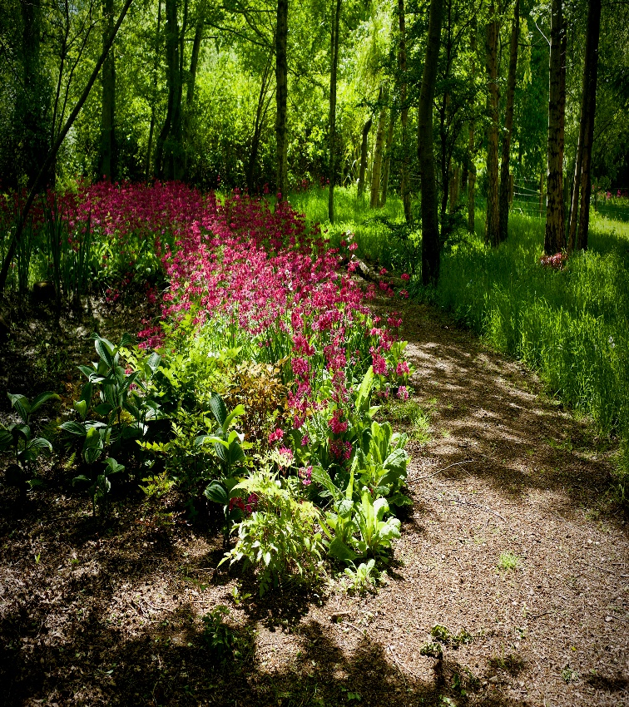Anne & John Nicol have three new grandchildren: Yarra, born in March and

Seren & Torryn (twins) born in April.

James & Clare Leslie-Melville have a grandson Wolf Archie, born in March.

**Deaths:**

Funerals have taken place in lockdown for: Isabel Lawrie, Gracie Summers, Ronnie Gray, Donald Bain, Margaret Bousie & Peter Williamson. The number limits for funeral attendees has been hard for many families and it is deeply moving to see local people lining the streets to pay their respects as the hearse passes. All bereaved families have been offered a memorial service in church at a later date.

**Contact details for Valerie Walker:** [**revalerian@gmail.com**](mailto:revalerian@gmail.com) **phone 01337 84799**