Lindores Litanies 7th Oct. 2020

*The Newsletter of*

*Lindores Parish Churches of*

*Newburgh and Abdie & Dunbog*

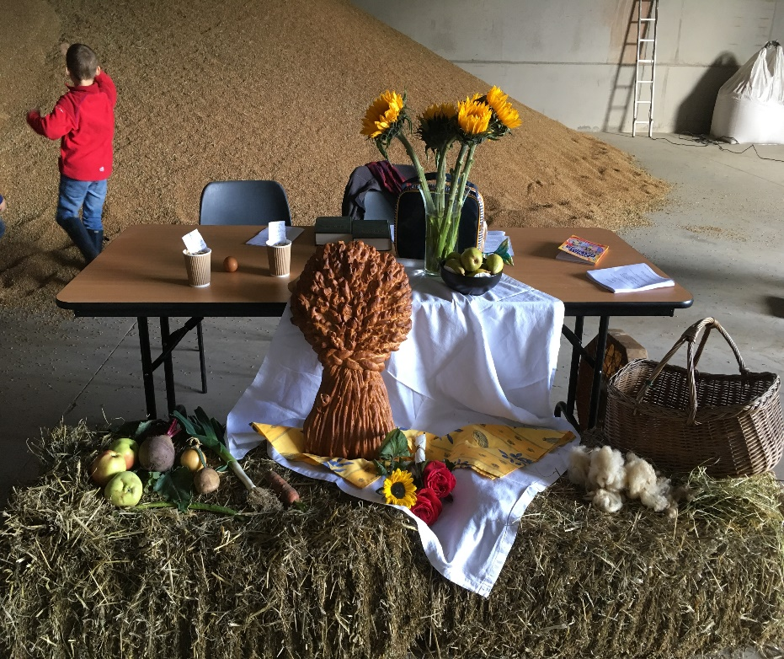**Harvest Thanksgiving**

Harvest services take place in Newburgh Church October 11th & Abdie Dunbog October 18th. Both services start at 10.30am.

You are invited to bring harvest gifts for Newburgh’s Friendly Food Fund, Gardens Road. Any dried and tinned foods welcome but the following would be particularly useful: Coffee, tinned meat, tinned fish, biscuits, beans and soups.

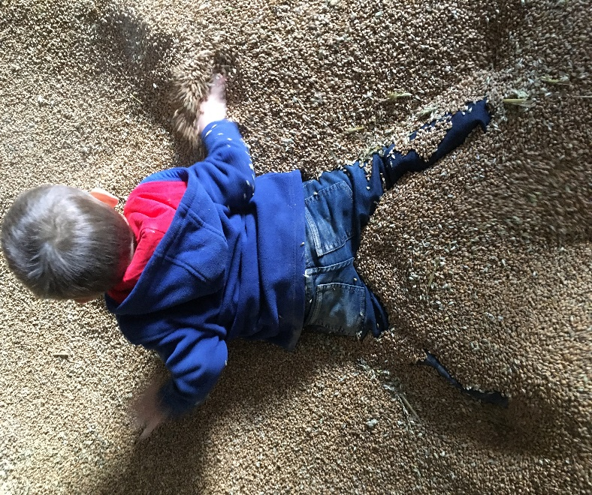

Sadly we can’t celebrate harvest in the Maitland’s barn as we’ve done in previous years: Some children may be particularly disappointed by this!

**Numbers in church are limited so to be sure of a seat please let Valerie know if you intend to come to either of these services**  (email [revalerian@gmail.com](mailto:revalerian@gmail.com)

Phone 01337 842799, mobile 07720 327766)

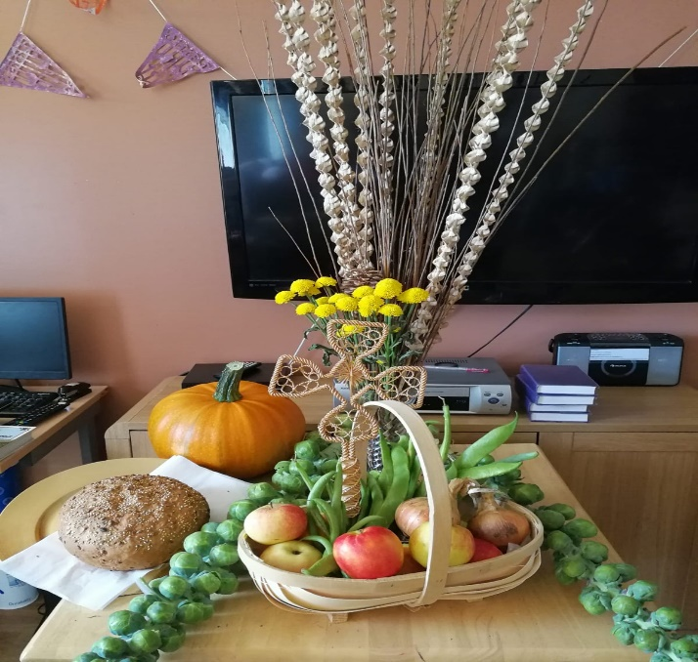**Abbotsford Care Home** held their own harvest thanksgiving yesterday. Along with the activities co-ordinator Jenny Brodie we planned a service with recorded hymns that residents could participate in. Some did harvest readings, prayers or poems, others just enjoyed the atmosphere. The sight of local grown vegetables, the feel of fresh apples and the smell of newly baked bread brought smiles of delight. There was gratitude too for the care of others & memories of harvests safely gathered in.

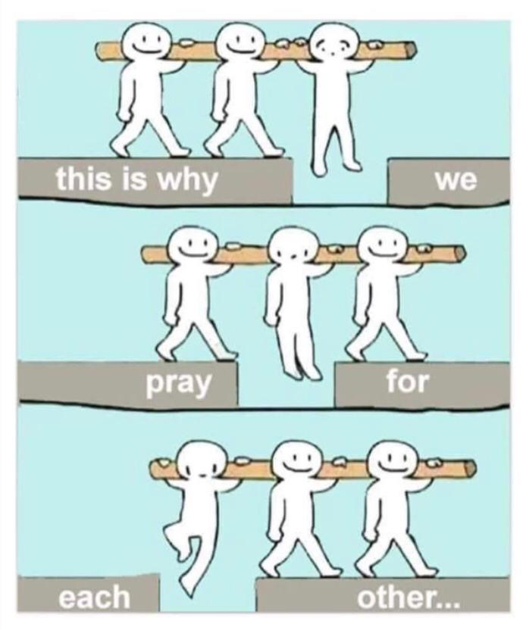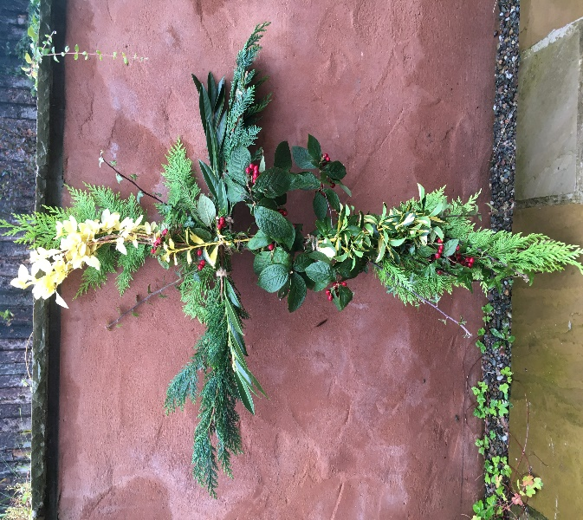 Last week I conducted an environmental funeral in Kirkcaldy for an Abbotsford resident, Laura Williamson. There would have been no mourners, flowers or music at the ceremony had it not been for her fellow residents and staff. Knowing Laura wanted a simple cross on her coffin they made this one with greenery and flowers from the garden. Knowing she loved Elvis Presley and Amazing Grace we crafted a service including a recording of this. Knowing there would be no others mourners four staff came along in their own time. I found it deeply moving to see her carers show this level of compassion and make such efforts to honour the life of someone they’d known for just a few short years. John Donne was right, our connections run deep.

**Running the Race** The sin of boastfulness is upon me without repentance, I confess.  
Over a year ago my nephew, the late Liz Brunton’s son, Craig Lockhart told me he wanted to run the London Marathon. I smiled in a parental way and said you go for it but you must train properly, it’s not like these Munros you keep walking!!! (Having never climbed anything more than the Lomond's when still at Bell Baxter).

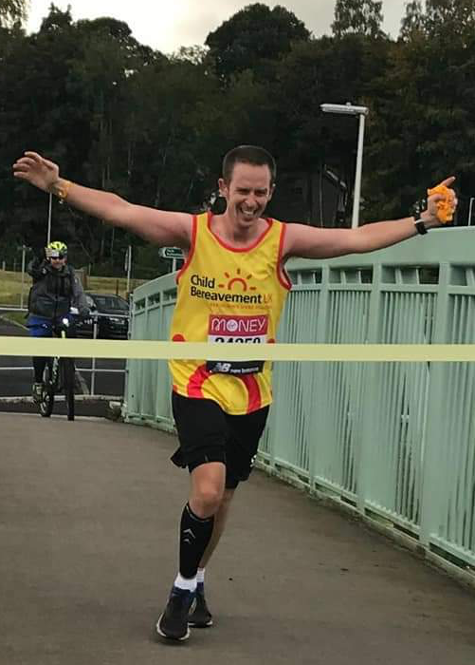Train he did, running a few miles at a time on the journey to & from his work to running up Munros as he became fitter. He applied to run the London Marathon and was accepted. (My son in law a very physically fit policeman in London has applied many times & been unlucky). We as a family all booked flights & hotels for August 2020 to go & cheer Craig on. Disaster!!! Corona did for the run. Not daunted Craig continued to train and was told his place would be retained for the next Marathon whenever it might be. He was then invited to do the virtual marathon, working out his own route of 26.2 miles, this he accepted & worked out a beautiful scenic route up hills & down dales. Again, as a family, we worked out where to be to cheer him on every step of the way. Sunday 4th October was the day, Saturday the 3rd the weather had plans to challenge the angels never mind Craig. 6:30 am on the 4th he attempted to drive the route, an absolutely no go, flooding wouldn’t let the car through never mind a runner. He planned another route quickly, again a no go. He went home for breakfast & to plan route 3 which his wife Louise & I drove with her frequently running to check paths & bridges as the route was mainly by the rivers Almond & Tay with no road access. This was to be the route with 2 laps. He set off at 10:15, later than planned, his buddy Daniel cycled with him encouraging all the way. As family we drove & ran/walked miles to be at places to cheer, even me lol. Well the deed was done, we all met others in Perth doing the Marathon & we cheered them all with our bells & whistles. Craig’s fundraiser was for Child Bereavement UK. He lost his own Mum at the tender age of 15 & very sadly he & his lovely wife lost a baby of their own. Running this Marathon raised a few ponds short of £1,500. Thank you to all who donated locally, it’s very much appreciated. We will certainly advertise again for the next London Marathon. Craig commented that the pain he was in at the end was truly worth it to help those that needed comfort. Margaret Stewart

**The world’s most dangerous wine**

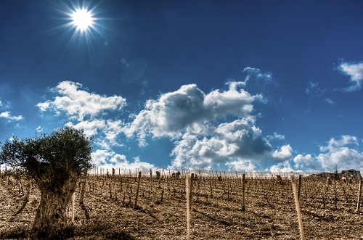Last week’s Gospel reading (Matthew 21) was all about vineyards so I decided to research wine growing in the Middle East. I was intrigued to read about a Syrian wine, *Domaine de Bargylus*, described as the world’s most dangerous wine and a winner of a Scottish ‘wine and war’ tasting, according to the Scotsman, March 2018. This vineyard in North West Syria, owned and run by two brothers in Beirut, is currently the country’s only surviving commercial winery. It has been too dangerous for the brothers to travel to their vineyard since civil war broke out in 2011, which presents huge challenges when it comes to harvesting the grapes.

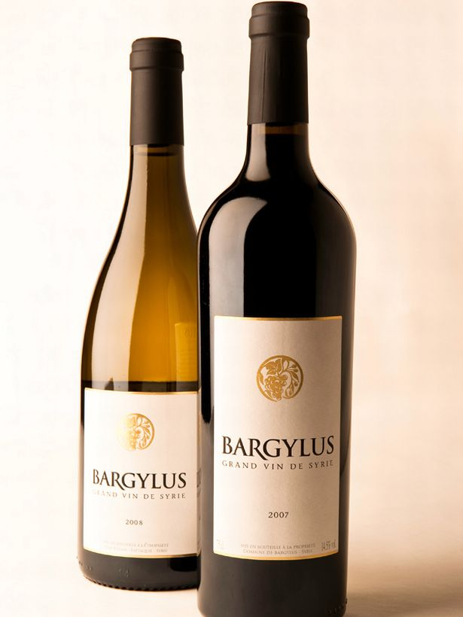Each summer, a sample of the ripening grapes is packed in ice and taken on a 4 hour taxi journey through Tripoli. If there are delays, as often happens at the Lebanon border, the condition of the grapes might deteriorate and further samples will need to be sent. When the harvest date is decided for each variety of grape the brothers send instructions to the Syrian team and keep in close touch by phone and email until the grapes and picked and the juice is finally vinified and bottled.

The 35 Syrian families employed in the vineyard and winery take huge pride in their continued work in the face of danger; mortar shelling and bombs have previously landed on the estate. The Saade brothers believe the survival and success of their vineyard is a symbol of hope for their loyal workers and for many other people in this troubled part of the world.

I was keen to taste the Bargylus so headed to Luvian’s in Cupar. Sadly they didn’t have any in stock but offered me another, equally good wine from the Lebanon. We discussed signs of hope in Matthew and the Middle East and better relationships between Catholics, Protestants and all Jock Tamson’s bairns. We also talked about the best temperature for drinking the Lebanon Valley wine, which Vince declined to let me pay for. He just asked me to enjoy this visual aid for my Sunday sermon and to let him know how it tastes; I told him it would be a pleasure ☺ Valerie

**Good Wine, Company and Communion**

The Rev Dr Malcolm Guite writes some wonderful poems and reflections. Here’s a few lines from his topical ‘*Quarantine Quatrains: a little celebration of wine’*

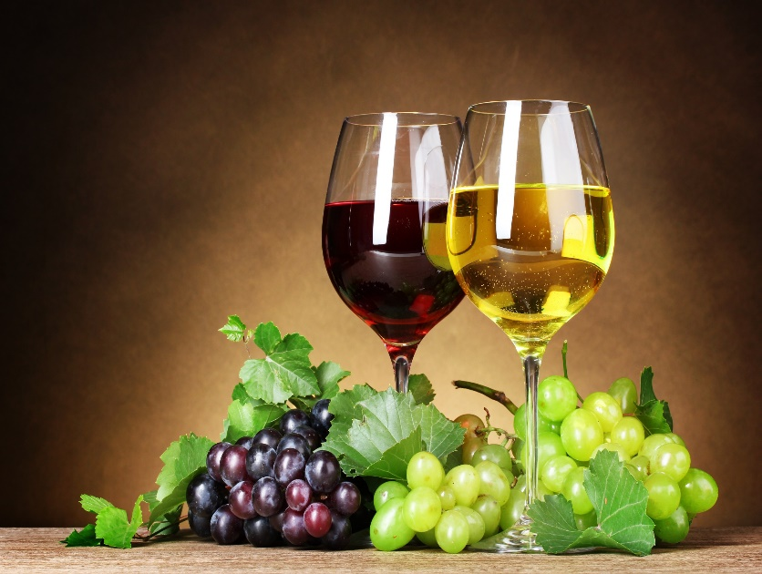 I’ll keep the rules my country has imposed

My life, like my small garden, is enclosed,

But still I’ll raise a glass and pledge my friends

Although, for us, the tavern door is closed

So with the poets let me praise the vine

And pledge my absent friends in vintage wine

Sensing, sometimes, the savour at my lips

Speaks of a love both human and divine.

And when I come to taste my life’s last drop,

When all that flowed in me comes to a stop,

Then let me see my saviour pledge his love,

Come close to me, and help me drink the cup.

**Future Church Services**

Harvest services: Newburgh October 11th, Abdie October 18th 10.30am

Celtic Communion at Newburgh: Thursday 22nd October 10.30am

Sunday service at Newburgh: 25th October 10.30am

Sunday service at Abdie Dunbog: 1st November 10.30am

**Acts of Remembrance** 8th November

9.30 Abdie Dunbog church

10.00 Newburgh church (no service in URC church this year)

11.00 Newburgh War Memorial

Celtic Communion Abdie Dunbog Thursday 19th November 10.30am

**Please let Valerie know if you intend to come to any of these services**  (email [revalerian@gmail.com](mailto:revalerian@gmail.com) Phone 01337 842799, mobile 07720 327766)

Elizabeth Pearson would like empty shoe boxes for our Parish contribution to the Blythswood Shoe Box Appeal 2020. These can be left at Melville Place or in either church.