Lindores Litanies 18th Sept. 2020

*The Newsletter of*

*Lindores Parish Churches of*

*Newburgh and Abdie & Dunbog*

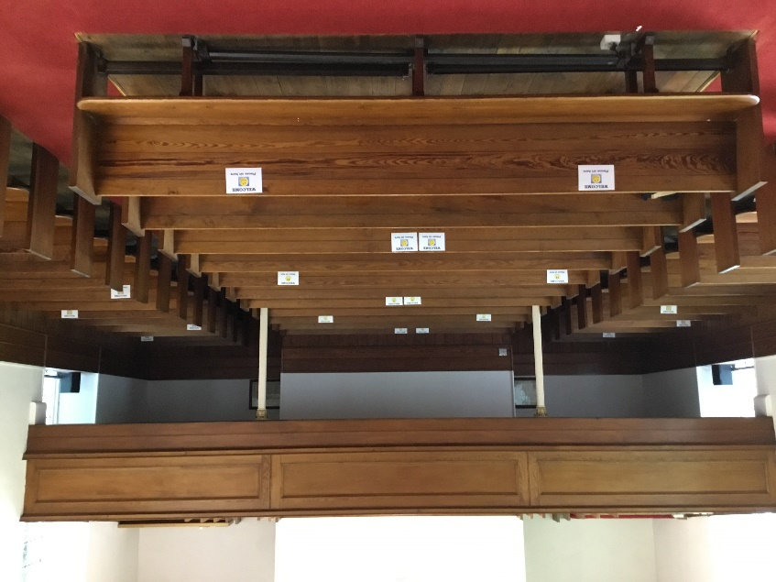**Re-opening Our Churches**

Having received approval from Session and Presbytery to open Abdie Church we were delighted to hold a Celtic Communion service there again yesterday. Many of us had been worried about how it would feel sitting 6 feet apart in unfamiliar, marked places and not being able to sing. Those who were worried about the hardness of the pews were invited to bring their own cushion. Despite the strangeness of this new normal everyone’s eyes were shining above their masks before the service ended. There was a real sense of joy at being back together in church and reconnecting with something greater than our fears.

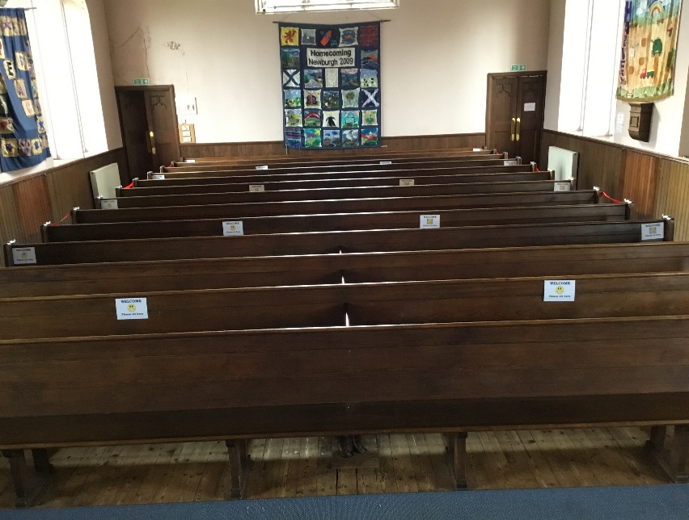We hope to open Newburgh Church for Sunday worship at 10.30am September 27th (depending on Presbytery approval). The first Sunday service in Abdie and Dunbog is on October 4th at 10.30am. **Please let Valerie know if you intend to come to either of these services** (email, text or phone). Newburgh can seat 30 folk, Abdie & Dunbog can seat 23 (more if one household sit together). Some might need wheelchair or extra space and we don’t want anyone to be turned away!

**The New Normal -** what toexpect when you come back to church

***Face masks*** or face coverings should be worn at all times inside church (except for worship leaders or readers in the sanctuary, staying 2 meters away from others)

***Track & Trace*** – your name and phone number will be requested on entering church (details to be held by Valerie in a secure file for 3 weeks).

***Collection Plate -*** please put any cash donations or envelopes into the offering plate by the entry door (we cannot pass the plate round during the service). Cheques or direct giving is safer than cash if that’s an option for you.

***Hand sanitiser dispensers*** are provided for you to use on entering and leaving church

***Please wait*** to be guided to your seat by a steward(like being at a wedding!) We need to follow a clockwise, one way system round church, entering from the left hand door and leaving by the right hand door. Try not to touch anything or anyone on the way to or from your seat.

***Remain seated*** throughout the service (sadly no hymn singing allowed) until the steward asks you to leave at the end.

***Toilet facilities*** will be available for use – please follow the cleaning guidance provided in that area.

***No tea or coffee*** can currently be provided after the service (both halls are considered out of bounds) and it would be helpful if folk could talk outside – at a suitable distance apart- rather than inside the building

It will feel strange at first, but it’ll be worth it to see each other and to be back in the buildings we love. We might even find some humour in it all: The below sign is adapted from the Northlake Lutheran Church.

**Sanitise Hands**

**Wear Masks**

**Sit in designated pews**

***HYGENESIS 24:7***

**Follow Me!**

Young evangelistic Americans sometimes wear wristbands with the letters WWJD –What Would Jesus Do? But maybe the more interesting question is: **How Would Jesus Do It**?

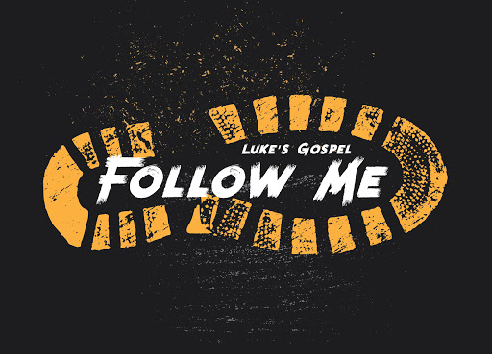‘Follow me,’ Jesus said – but how? Literally walk behind someone and plant your own feet in their footsteps? A bit silly; and you might get arrested. Or adopt their ideas, share their values?

I recently undertook a short course in digital marketing, and learned that worldwide, as of April 2020, 2.5 billion people use Facebook, with You-Tube and FB Messenger users each totalling 2 billion. Facebook is the world leader, with audiences for LinkedIn, Twitter and Instagram also huge, and growing. WeChat, in China, has 980 million users.

Social media is everywhere; and democratic. Do you ever buy anything without looking at customers’ reviews? Nowadays, companies cannot tell customers what to believe about their products or services – instead, we tell each other. Have you ever posted on Trip Advisor, for example, after a visit to some stately home or restaurant or AirBnB? Companies must engage with their customers and take these comments seriously.

The digital landscape has completely transformed marketing over the last decade. You can assess the effectiveness of companies’ marketing efforts by looking at engagement in their posts on various platforms. For example, I looked at the last ten posts on the Scottish Poetry Library’s (SPL) Facebook page. I use the SPL website regularly, as a first-class source of info on Scottish poetry, including biographies and full copies of poems. I counted how many Likes, Comments & Shares each had attracted, and was surprised at how low (often single figures) their social engagement was. This, I felt, was sad – a missed opportunity. Surely we would all love to have more poetry in our lives? Otherwise, poetry might seem exclusive, incomprehensible, even irrelevant. How about Church Facebook pages? How many likes, shares & follows? Which posts work well & which go nowhere?

By contrast, my Malaysian friend Kurt, having just moved to Glasgow, has set up a TikTok account as his way of ‘learning Scottish.’ Within four months, he has built up a following of 39,000 people – not all youngsters either, apparently, but including a fair number of middle-aged women! TikTok uses short home-made music and dance videos to communicate. To learn Scottish by TikTok, using Kurt’s method, you ask people for suggestions, follow them up, and get into dialogue. So ex-RAF Kurt with his PhD and four previous languages can now dance the Slosh, drink Irn-Bru, choose authoritatively between a white pudding and a pizza crunch, and make a wildly entertaining attempt at ‘It’s a braw bricht moonlicht nicht the nicht’. Sometimes he is even recognised in the street – or down by the river in Newburgh!

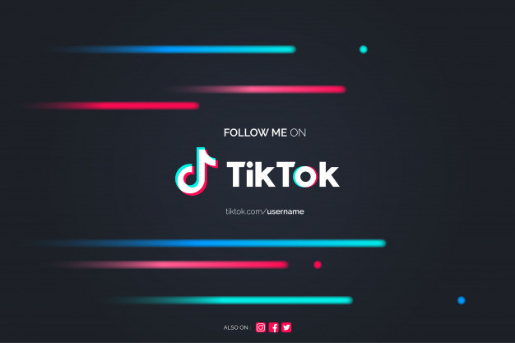This might seem trivial, but in less than four months of living in Scotland, Kurt has made friends all across the land, and understands how many Scots lead their lives. He uses his platform to challenge bullying, racism and homophobia, from a position of trust where he can be genuinely influential. I take my hat off to him. He knows TikTok might not last, with US’s recent accusations to China over alleged spying; but it has been real.

If Jesus were alive today, would he be on TikTok? Or even Facebook or Twitter or LinkedIn? The Bible tells us that Jesus became so popular for a while that he couldn’t go anywhere without being followed by crowds of people hanging on his every word. They Liked, and Commented, and Shared. Eventually, they Followed (for a while.)

How Would Jesus Do It today?

***Helen Welsh***

Elizabeth Pearson would like empty shoe boxes for our Parish contribution to the Blythswood Shoe Box Appeal 2020. These can be left in either church.

**Valerie Walker’s contact details:**

email [revalerian@gmail.com](mailto:revalerian@gmail.com)

Phone 01337 842799, mobile 07720 327766