*The Newsletter of*

*Lindores Parish Churches of*

*Newburgh and Abdie & Dunbog*

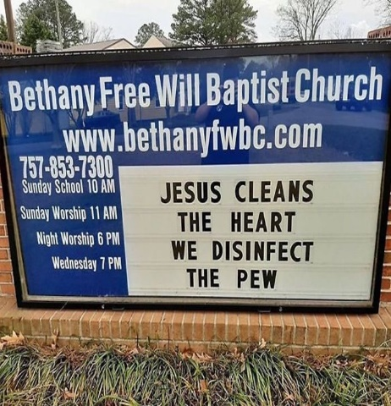

Lindores Kirk Session are hoping to open our churches for worship in mid September. This will require a lot of health and safety measures to be put in place beforehand.

The Church of Scotland General Trustees have provided comprehensive advice on cleaning congregational buildings, available on their website, as well as detailed instructions on how people can gather safely for services. Hopefully we’ll have enough volunteers to help us meet the many safety requirements!

***A Computer Prayer***

*God bless my friends and family, wherever they may be.*

*Keep them safe from fear & harm; they’re very dear to me.*

*And God, there’s one more thing I’d like to ask of you*

*Knowing how you care for all – bless my computer too*

*I know it’s not in common prayer to bless a motherboard  
But times are very different now & I need your help my Lord.*

*You see, that little metal box holds more than odds and ends.*

*Inside those small compartments are so many of my friends.*

*I know so much about them, by the kindnesses they give,*

*And this little scrap of metal takes me in to where they live.*

*Their words of hope & caring bring me close to them and you.*

*Sharing joys & sorrows, that’s how our friendship grew.*

*Please, take an extra minute from your duties up above,*

*To bless those in my address book that’s filled with so much love.*

*Wherever else this prayer may reach, to each and every friend,*

*Bless each email inbox, and the person who hits send.*

*When you update your heavenly list, on your own CD-ROM,*

*Remember each who’ve said this prayer, sent up to God.com. Amen*

**Virtually connected**

People have been using various ways to keep in touch with each other whilst our churches are shut. Electronic devices have been wonderfully helpful in this. Many of us have acquired iPads or tablets (or learnt how to use them!) for the first time. Danny Ferguson, one of our oldest elders, with the wisdom of his years (and some help from his family) is now able to watch the birds in his son’s pigeon loft on his new iPad. Some of us have met online in virtual chat rooms such as Zoom, with varying degrees of success. Many people say that lockdown would have been much harder without the internet. Elspeth Gibb sent in this delightful computer prayer.

**Zoom Meetings**

**Margaret Stewart reflects on Friday morning zoom meetings:**

We are having a zoom meeting to meet for Morning Thoughts on Friday she said.

What’s that I say? Does it mean we talk very quickly? But we can’t meet I say, unless we are outside and socially distancing!! What if it’s pouring with rain, where would we meet, what would we sit on?

No, no, she says, it’s when we can talk to each other on the computer or an ipad /tablet or on a mobile phone, and we can all see each other too from wherever we are.

That sounds like a good idea say I, how do we go about it?

So Valerie does all the hard stuff and sends all of us that wish to take part, a code number and password and Bob’s your uncle, up pops a picture of a camera with easy instructions and there were several weel-kent faces with smiles, after we got over the fact that we didn’t need to shout at the computers etc. It was a wee bit frantic at the beginning when we realised if we didn’t want anyone else to hear what we were saying to our own household, like; shut that door, can you bring me a cuppa please, turn the radio down, get out of this room please I’m busy, we learned to press the mute button. Sometimes we forgot to put our faces on screen or position the camera on our face and got a view of the ceiling. Occasionally people looked to be upside down or someone’s dog or cat appeared on screen.

Over the months we have had great conversations, chatted about the good parts of the previous week, things that have made us happy, who or what we were worried about (not naming names unless wanting to) and praying for those that need support. We bring our own coffee and continue our thoughts for others for approx. 30 minutes then those who don’t have to rush off stay for a good old chinwag.

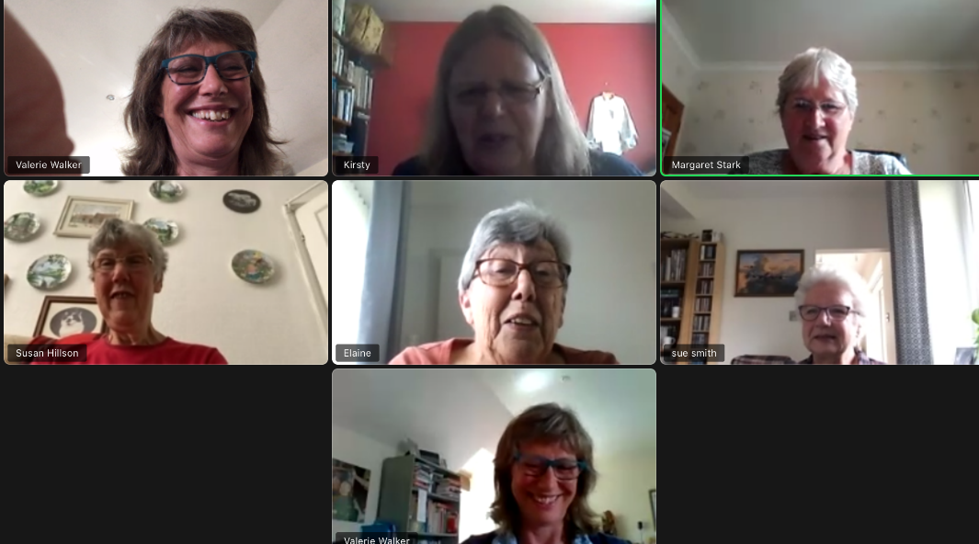

Zoom calls I have discovered are a great way of communicating, anywhere in the world, one of our group once dialled in from Greece.

Our Friday group, which sometimes extends to 12, includes the Sues from Northampton and Greater Manchester. Friends and relations are always welcome. If you join on more than one device you can appear in more than one window!

I even take part in family quizzes now, much better than just chatting on a phone, although you can use a landline phone and dial in to a zoom conversation with several other people at the same time which gives a sense of belonging. The zoom calls have been a Godsend especially during lockdown when I for one couldn’t get out to visit or to see my family especially those down south. The isolation wasn’t great for any of us, even if someone else was in the house it could be a lonely place.

Some places have zoom church services now as we can’t use the church as yet and folk not able to go to the church anymore can still take part. Could this be the way forward? Time will tell.

*Margaret Stewart*

**Coffee and Chat at Jill’s** on Thursday mornings was something many of us missed during lockdown so we decided to meet each other on Zoom at 11am every week instead. For those of us living alone it felt like a life line to see other faces and catch up on news. The collective wisdom of the group enabled us to help each other with practical issues from technology to shopping and gardening. As only one person at a time can be heard on Zoom we had to listen carefully to each other and found ourselves communicating more effectively than if we were all in one room. Having time to hear each other’s stories helped us get to know each other better; an unexpected consequence of meeting in this way and a real blessing for us all.

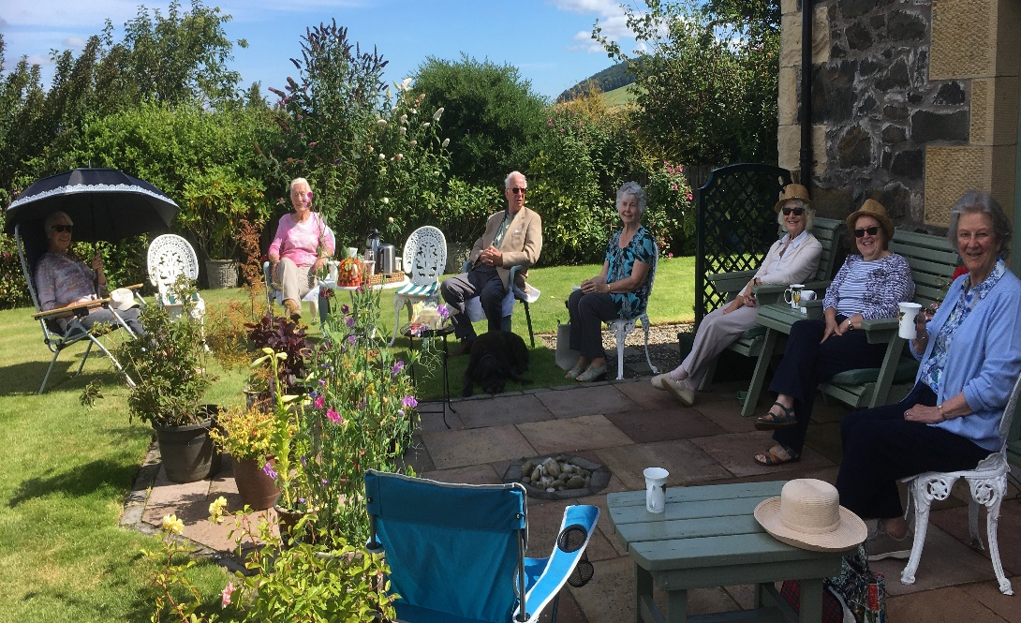

Last week we managed our first socially distanced coffee and chat since March. Thanks to Grace and Jill for their hospitality.

***National Week of Prayer for church and country***organised by the Rt Revd Dr W Martin Fair, Moderator of the Church of Scotland from Monday 17 to Saturday 22 August. At 8am each morning a pre-recorded reflection will go live on the Church of Scotland website and on Facebook. These will include contemplative music, Scripture readings, a brief ‘thought for the day’, a prayer and blessing. Additionally there will be a suggested prayer activity that you can choose to take up at some point during the day. In the evenings, there will be a ‘live’ gathering on Zoom in which we hope many from across the country and perhaps further afield will participate. These will commence at 8.30pm. Zoom meeting ID 856 8913 7107, Passcode 2020.

**Scottish Country Dancing**

I have just been informed by the Perth and Perthshire Branch of the Royal Scottish Country Dance society that all autumn classes have been cancelled.  I am therefore cancelling the autumn session of our class.

I am really missing dancing, and, apart from missing the exercise, I am missing seeing all of you.  I hope when we can resume dancing you will all come back to the class and maybe bring some friends as well.

Until then, keep safe.

***Netta Berry***

***Zoom Sunday worship****.* Bill Hunter, our interim moderator, is extending an open invitation to anyone who wishes to join the Howe of Fife for worship at 10am on Sundays. Zoom code 279 4034 482 passcode 5963. Some of us joined the Cluster Songs of Praise on Zoom last Sunday and greatly enjoyed it.

***Christmas Windows*** Kathleen Black has decided to step down from organising Newburgh Church Christmas windows. Although this has been a highly enjoyable and successful event over the years current restrictions may preclude our holding it this year. If anyone else would be willing to take this task on please do get in touch.

**Open Garden:- Lindores House, KY14 6JD, Sunday, Aug. 16th 1-5p.m. Entry £5 (proceeds to N.E. Fife Scout Group, Newburgh) No refreshments provided but visitors welcome to bring their own picnic and rugs/chairs.**

Some of the keen Abdie gardeners went to Willowhill at Newport recently. They wax lyrical about it and little wonder, the photographs, kindly sent by Chloe Turcan are beautiful. Willowhill is beside the strawberry hut as you turn left to Tayport at the roundabout going towards the Tay bridge.   
Address -:    Willowhill,  Forgan,  Newport - on - Tay,  DD6 8RA  
Open Mondays, Fridays and Saturdays  17th July  -  29th Aug.  2pm - 5pm  
[www.willowhillgarden.weebly.com](http://www.willowhillgarden.weebly.com/)

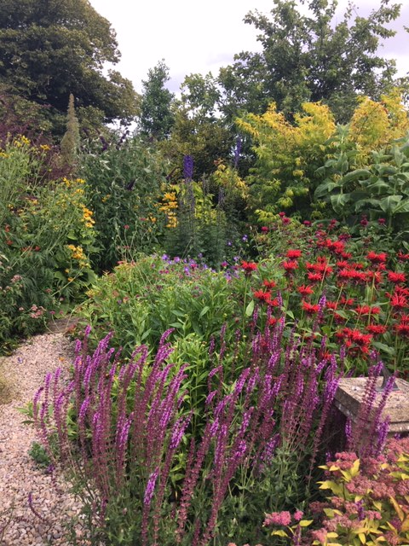 Doriel Crawford’s comments:

*This is a lovely garden that is continually being developed with very colourful flower-beds at all times of the year. There is a beautiful large pond and a further colour themed long border has recently been created with a walk through a flowery meadow. Steps down towards the house with alpine planting lead to a circular lawn with herbaceous beds, with an added bonus of plants for sale. Highly recommended.*

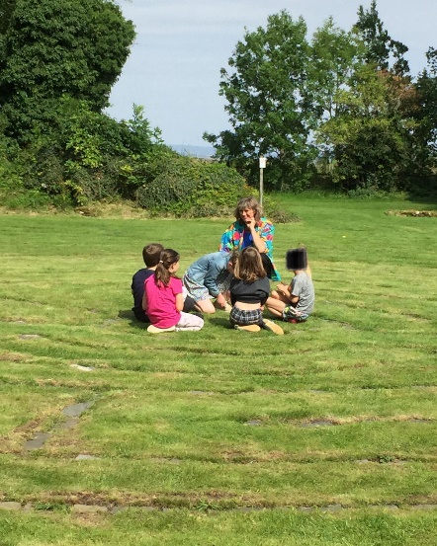

On Monday 10th August, two years after they laid the first stones, local primary children came back to the labyrinth, along with Mairi-Jane Young from the Haven learning Hub. The children enjoyed meeting friends again and discussing what they were glad to be leaving behind and what they were looking forward to when returning to school on Wednesday. We are grateful to the McKenzie-Smiths for their kindness and hospitality in facilitating this day of hope and fun.

**Contact Details: Valerie Walker**

**Email** [**revalerian@gmail.com**](mailto:revalerian@gmail.com)

**Phone 01337 842799**

**Contact details:- Valerie Walker,**

**e-mail** [**revalerian@gmail.com**](mailto:revalerian@gmail.com) **, Tel.01337 842799**