Lindores Litanies 9th Dec. 2020

*The Newsletter of*

*Lindores Parish Churches of*

*Newburgh and Abdie & Dunbog*

**Scarecrow Nativity**

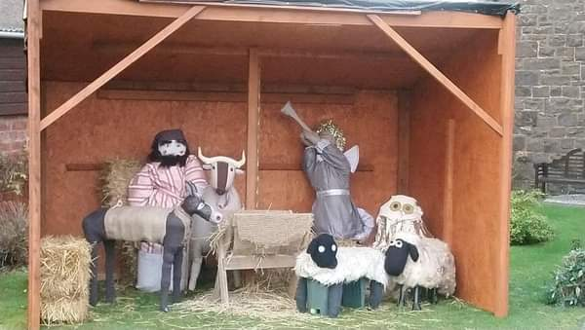Newburgh residents may have noticed a stable installation in the church grounds. This is part of the scarecrow nativity scene we’re creating with the help of the primary schools, Abbotsford nursing home & others. Thanks to the enthusiastic response for homemade angels, shepherds, kings & animals a new character is added every day, like a three dimensional Advent Calendar.

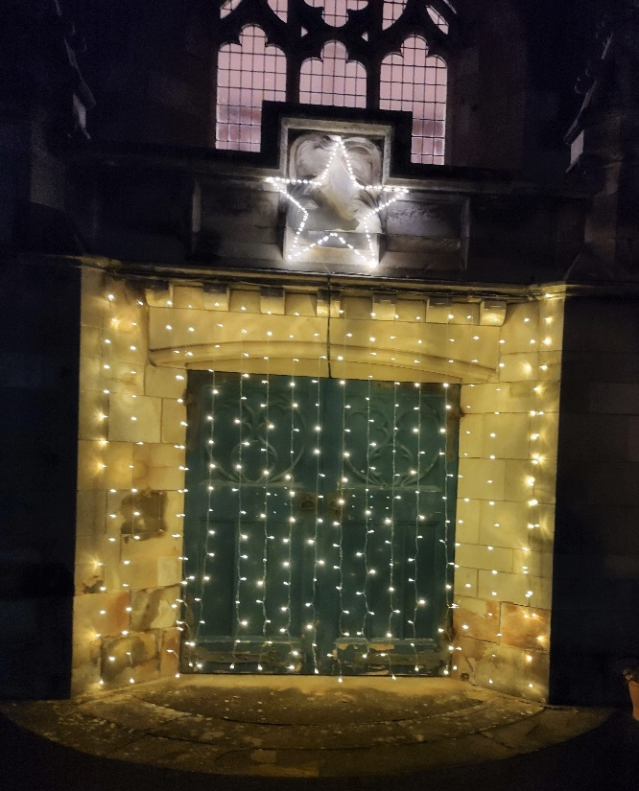The staff at Lindores Abbey Distillery made a scarecrow king and a gazebo for all the wise men and the camel, yet to be added, as they travel from the East of the garden toward the star and moving curtain of lights. Hopefully we’ll soon have a choir of angels, if we can work out a better way to secure them to the roof!

Visitors are welcome to come take a closer look and bring a gift to the crib (for the food fund) on Christmas Eve when the grounds will be open for a few hours, with the usual social distancing.

Hoping you have a peaceful and blessed time whatever you do this Christmastide

*Valerie*

**We Still Remember Them**

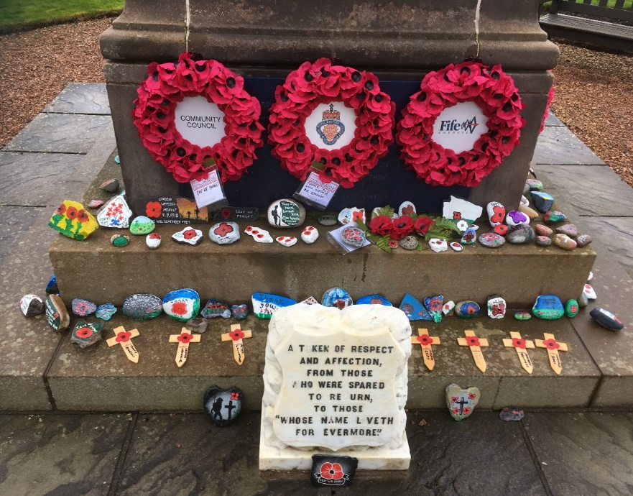The restrictions on outdoor gatherings didn’t prevent the people of Newburgh making individula tributes at the War Memorial this year. Every child in school, along with many adults, painted stones to lay on the war memorial steps. There was a glorious variation in colour and design; some also bore names or initials. There were so many stones they covered the steps on all four sides of the memorial: A beautiful, visual tribute to the fallen.

**Seasonal Remembrance**

We’ve held a seasonal remembrance or *Blue Christmas* service in Newburgh church for several years now. It offers a time of peaceful reflection and thanksgiving for the lives of those we’ve loved and are likely to miss at Christmas. People usually write a name or message on silver/ gold star to hang on our Christmas tree and light a candle as they remember loved ones. The congregation includes some folk who traditionally come every year and others who have been more recently bereaved.

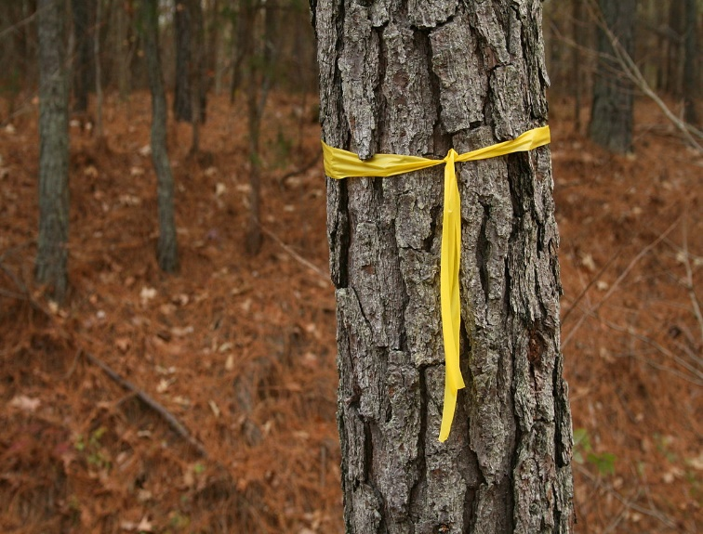Mindful that some people don’t feel able to come to church at the present time we’re inviting anyone who so wishes to tie a ribbon on the cherry tree in the front garden at Newburgh Church. These can be tied round the trunk or on a branch, using whatever size or colour of ribbon you chose.

The remembrance service is at 3pm on December 13th. Ribbons can be added from that date anytime until Jan 6th.

**OUR PATRON SAINT by Helen Welsh**

My colleague Murray was recently tasked with creating a cocktail to mark St Andrews Day, and set about finding out who St Andrew actually was. He found to his surprise that Andrew had been an apostle, but known chiefly as Peter’s brother, with very little recorded of his own exploits. So Murray called his cocktail **‘Peter’s Brother’** and you can find the instructions on how to make it at

[St Andrews Day 2020 | Lindores Abbey Distillery](https://lindoresabbeydistillery.com/st-andrews-day/?unapproved=18713&moderation-hash=78707b9e45af6926609075d986d88a25#comment-18713)

I was intrigued, but a bit disbelieving, that Andrew’s main claim to fame was being Peter’s brother. (Having said that, if I had to choose a big brother among the disciples I’d definitely go for Peter – obstinate, impetuous, loyal-but-flawed – although you’d probably spend a lot of time trying to get him out of various scrapes.)

If contributors to the Internet are to be believed, it seems that Andrew and Peter’s father was Jonah, aka John. Jonah’s business partner and best friend was Zebedee, who also had two sons – James and John. Jonah and Zebedee’s business was fishing, and was located at Bethsaida on the northern shore of the Sea of Galilee. It was unusual but significant that they gave their sons Greek rather than Hebrew names, perhaps indicating a certain openness to cultural diversity. In any case, the name Andrew is said to represent two things – strength and curiosity. And so, off went Jonah and Zebedee’s workforce to follow Jesus, no doubt leaving the business short-handed.

Remember that scene where 5,000 hungry people are hanging on Jesus’ every word? It happened at Bethsaida, and it was Andrew who found the little boy with the loaves and fishes and took him to Jesus, leading to the astonishing feeding of the massive crowd. So Andrew was strong, curious and practical.

After Jesus’ death he continued to preach the gospel, and inevitably ran into trouble. He was crucified in Patras, Greece, in AD 60 (aged 50ish) and asked for the X-shaped cross – because he felt it would be too presumptuous to die on the same kind of cross as Jesus.

He never travelled to Scotland, but his bones were said to have been brought here, many centuries later (I find this hard to believe but you never know). There are also stories about a white cross appearing in a blue sky at various propitious moments (really?) – hence the Saltire.

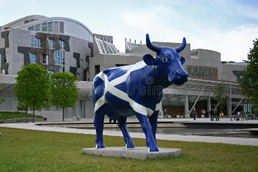As well as being patron saint of Scotland, Andrew enjoys the same status in Russia, the Ukraine, Romania, Barbados, and many cities across the world – including Patras, where he died.

It may be a few days late to celebrate St Andrews Day; but let’s just say the calendar’s a bit mixed up this year and do it anyway. So raise a glass, or a cup or a mug, to St Andrew – for strength, curiosity and practicality; and for sticking up for your siblings.

**A Seasonal Quiz from Kathleen Black**

***The answers to the following clues all pertain to either Christmas or Winter. Some cryptic and some general knowledge (Number of letters provided)***

***1. Illuminations for little people (5,6)***

|  |
| --- |
| ***2. Was she an army mother? (4)*** |
| ***3. Spruce, fir, etc (9,4)*** |
| ***4. Does she sing Christmas songs? (5)*** |
| ***5. Holly’s pal (3)*** |
| ***6. Odd tables in Jesus’ birthplace? (6)*** |
| ***7. A gift without a vowel (5)*** |
| ***8. Oh no it’s not a traditional Christmas show! (9)*** |
| ***9. Kiss under this parasite (9)*** |
| ***10. Are you likely to gobble this at Christmas? (6)*** |
| ***11. Is this a well behaved child on top of the tree? (5)*** |
| ***12. Listen to the sparkling Christmas decoration (6)*** |
| ***13. Jesus’ first bed – of German extraction? (6)*** |
| ***14. Do the law scenes make a good king? (9)*** |

**Scripture Cake recipe -** from Elizabeth Pearson who advises using the King James Bible for the best flavour.

12oz 1 Kings chapter 4: verse 22

6oz Jeremiah 6:20

8oz each 1 Samuel 30:12

4oz Numbers 17:8

2 Tablespoons 1 Samuel 14:25

4 articles Jeremiah 17:11

8oz Judges 5:25

1 pinch Leviticus 2:13

2 teaspoons Amos 4:5

2 teaspoons 2 Chronicles 9:9

4 tablespoons Jeremiah 35:5

**Place all ingredients in a large bowl: Proverbs 23:14**

 **CHRISTMAS/NEW YEAR SERVICES **

**LINDORES PARISH CHURCH**

**SUN 13th DEC SUNDAY SERVICE, ABDIE DUNBOG CHURCH, 10.30am**

**SUN 13th DEC SERVICE OF REMEMBRANCE, NEWBURGH CHURCH 3.00pm: A quiet service of reflection to remember those we have lost. Ribbons may be tied on the cherry tree in the church garden until January 6th.**

**SUN 20th DEC SUNDAY SERVICE, NEWBURGH CHURCH, 10.30am**

**THUR 24th DEC WATCHNIGHT SERVICE, 11.30pm,**

**ABDIE DUNBOG CHURCH**

**FRID 25th DEC CHRISTMAS DAY SERVICE, NEWBURGH CHURCH 10.30am**

***SUN 27th DEC NO SERVICES IN EITHER CHURCH – Link to Church of Scotland online service to be made available soon***

***2021***

**SUN 3rd JAN SUNDAY SERVICE, ABDIE & DUNBOG CHURCH 10.30am**

**SUN 10TH JAN SUNDAY SERVICE, NEWBURGH CHURCH, 10.30am**

***Please let Valerie know if you would like to come to any of these services so you can be sure of a seat and we can abide by the current regulations.***

email [revalerian@gmail.com](mailto:revalerian@gmail.com) Phone 01337 842799 mobile 07720 327766