*The Newsletter of*

*Lindores Parish Churches of*

*Newburgh and Abdie & Dunbog*

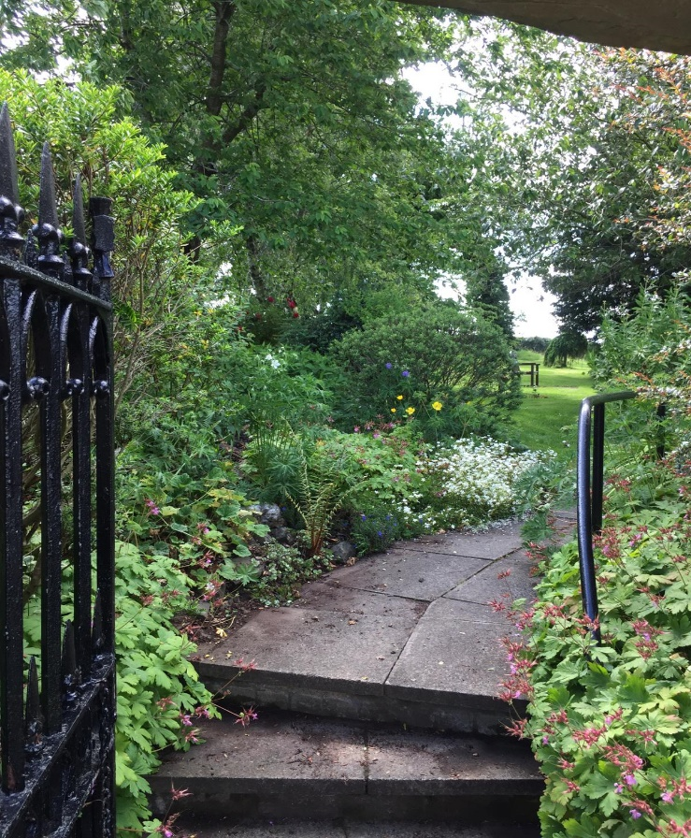A Litany is a type of prayer or supplication, with a call and response between leader and congregation. It can also mean a long or tedious tale, eg a litany of woes, often retold to unwilling listeners!

The purpose of our Lindores newsletter is to provide a litany of hope and light relief; to better connect us during our enforced absence from church.

I’m hoping you’ll send in lots of material for future editions e.g. photos, stories, poems, prayers, gardening tips, good reads, recipes, brain teasers or anything else to delight and/or inform those we miss seeing on Sundays.

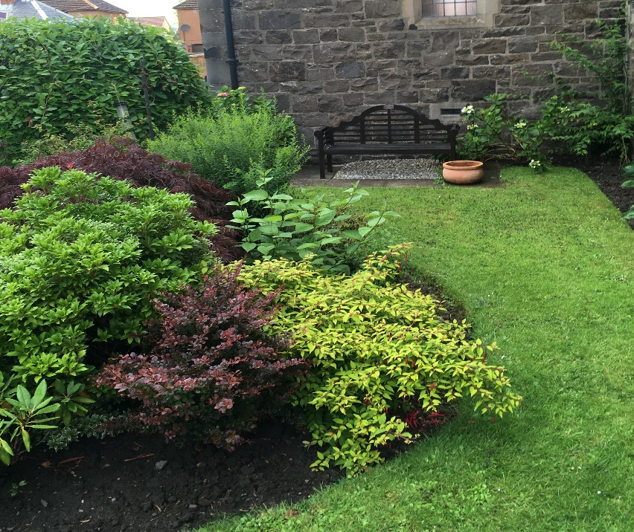

Although our church doors are currently locked the gardens are still open and, thanks to the devoted efforts of Jim, Clare, Scott, Sally and Margaret, both church gardens provide a beautiful place to sit quietly and be close to God in nature.

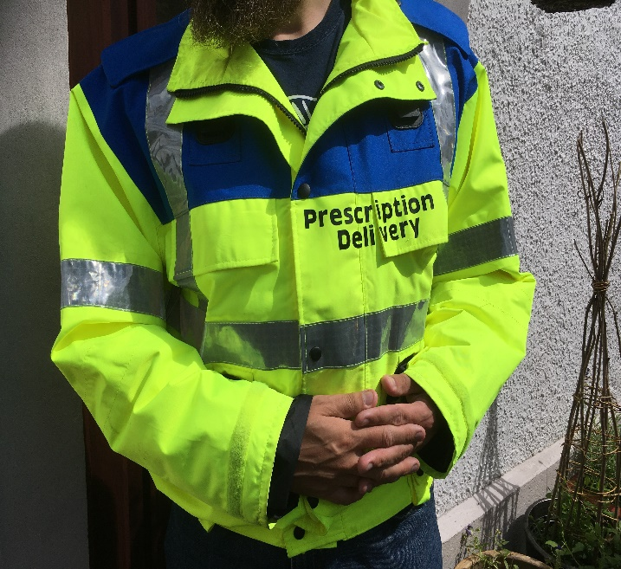In March, Valerie was asked by Newburgh Surgery to organise a community prescription delivery service. As a ‘shielding’ household John and myself readily agreed to be the co-ordinators and receive daily landline phone calls – we were going nowhere! A local man, Jim, had already offered his services as the driver and kitted himself out in an easily identifiable jacket.

**The Bee Gees : Free prescription delivery service**

Davidsons Chemist welcomed the service with open arms and said we should have a name. I suggested the Gibbs, but the consensus of the staff was The Bee Gees!! (I can categorically say that we do not sing!)

Since then, no matter where we go in the garden, or which room we go into, the constant retort is “have you got the phone?”. It sticks closely with us - along with clipboard and pen!

During daytime, almost all the calls are for a prescription delivery. I have only once answered the phone and said “The Bee Gees – Elspeth speaking. Would you like a prescription delivered?” Yes, you’ve guessed……… that particular call was from PRI physio department, wanting to talk to John…………I didn’t do that again!

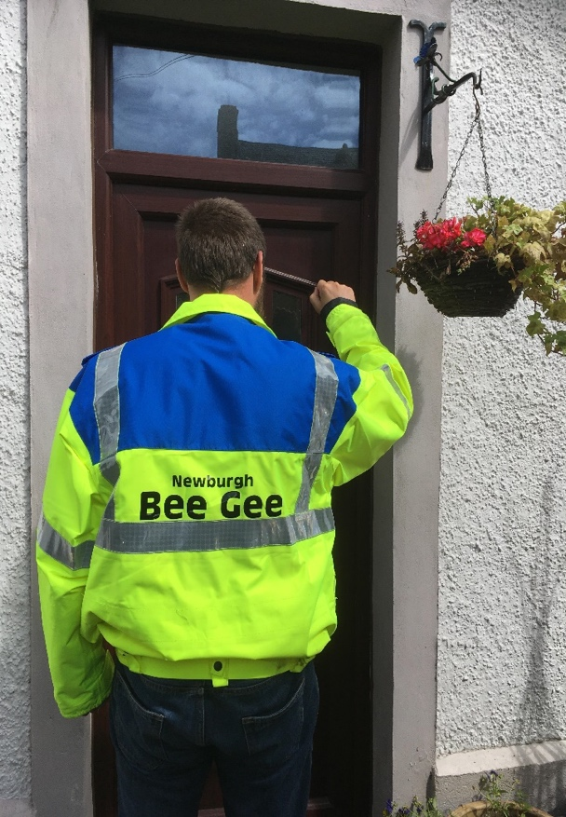The system is working well, phone calls come in, the list is emailed to Jim, who forwards it to the staff at the Chemist, and they get everything ready for uplift the next morning. Jim regularly delivers prescriptions 5 or 6 days a week and is recognised locally as ‘The Medicine Man’. People often comment that his cheery smile and friendly manner brightens up their morning, as does his ‘uniform’.

During this awful lockdown, it has been a real pleasure for us to help out in some way. Having a quick chat with people we’ve known for a while, and others whom we’ve never met, has helped with the tedium of being locked in. When our delivery service ends on July 15th and things get back to the new normal, I’m going to miss the chat. Hopefully we’ll all be out and about and able to see each other soon. Stay safe and well everyone! Elspeth……. (and John – the other Gibb)



**A New Normal**

Every normal was once new....

it did not arrive,

but came to be.

Time and tide,

call and creativity,

all played their part

in where we arrived -

in this life in God

which we called normal.

And what of Christ,

our hope, our strength -

whose normal,

once, was family life,

learning carpenter’s ways?

Did he welcome

his call and challenge,

this change to all he knew?

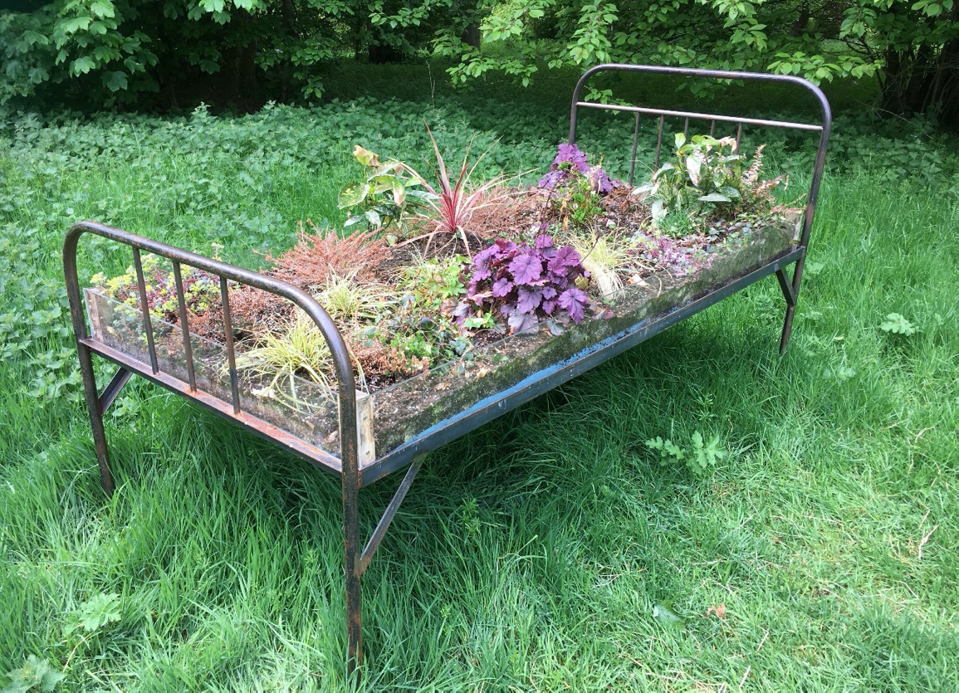  Did he also feel loss,

longing for the familiar, even while bringing life?

And one day

our new normal,

(still becoming)

will also bring

new hope -

new ways to be.

Things will change

again and always,

for life and faith

never stand still.

God is making all things new.

Even what is normal....

*Lezley Stewart (*Secretary for Recruitment and Support; Church of Scotland)

**Normal Weather for July?**

Cheery helpers undaunted by the rain at Newburgh church strawberry tea July 2018.

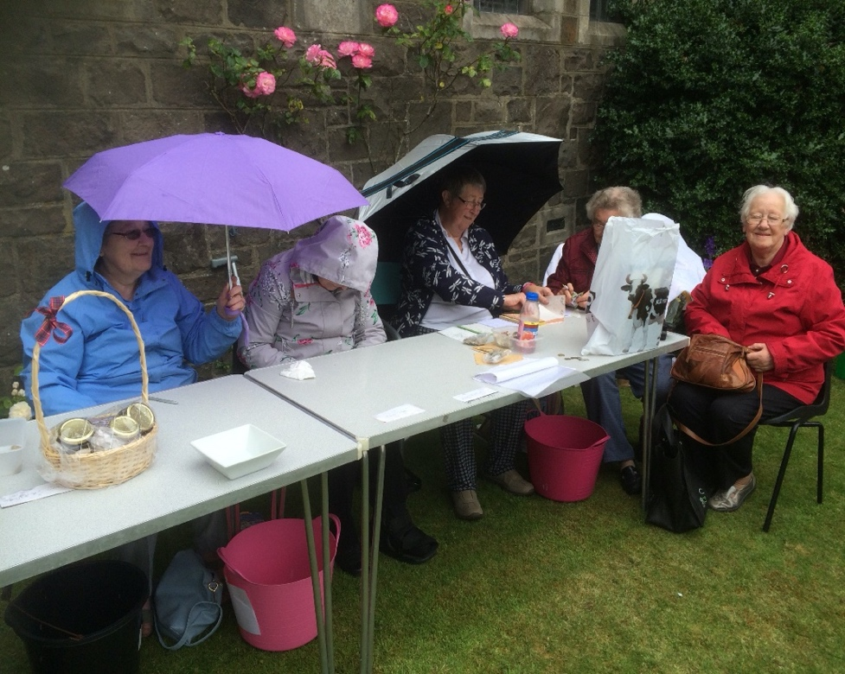Margaret Bousie’s smile would brighten any dull day. I had an unusual and poignant moment when we laid her to rest in Newburgh cemetery last month. There was a deep silence after the Celtic Blessing, when a Sunday congregation would normally sing ‘Amen’. Then a cuckoo, hidden in a nearby tree, voiced its own fitting, characteristic conclusion.

Many folk tell me they miss the Newburgh quiz – so here’s one from Kathleen Black;   
 the answers are all herbs or spices.

1. Sounds like you know this looking at a clock __________________
2. For remembrance __________________________
3. The dog in discontinued children’s tv programme __________
4. …… and the lion! ______________
5. Wise man ______________
6. First name of character in Faulty Towers _________
7. Pleasant first name of lady who drew Flower Fairies (2 words) _________
8. Cove and frond __________
9. Place were money is coined _______________
10. 100 homes of bees! _______________
11. Morecambe, Botany, etc. _____________
12. Go bare (anagram) _______________

Please send any suggestions, comments or material for future editions to Valerie Walker, [revalerian@gmail.com](mailto:revalerian@gmail.com) or phone 01337 842799.