Lindores Litanies 14th May 2021

*The Newsletter of*

*Lindores Parish Churches of*

*Newburgh and Abdie & Dunbog*

**New Church Website**

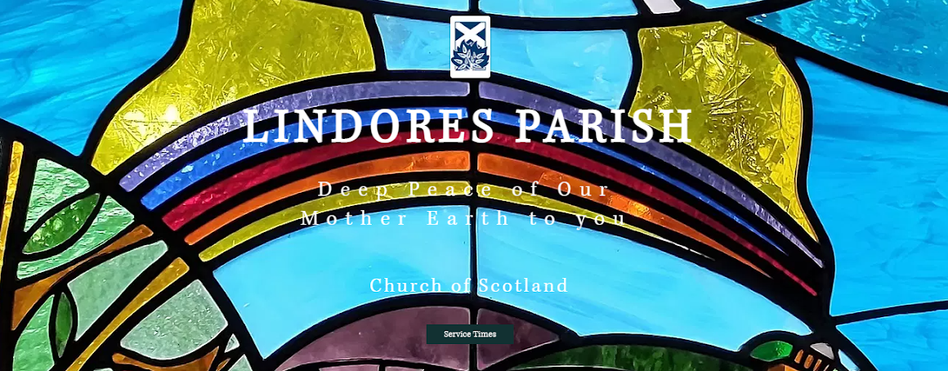

Our new church website is now available: lindoresparish.com

Our website aims to provide an insight into life in our Parish and extend a welcome to any visitors or enquirers. Please invite your neighbours, friends and family to have a look at it. Any contributions (photographic or otherwise), comments or suggestions for improvement will be gratefully received.

All our church service times are now easily accessible via the green box labelled Service Times on the homepage and are regularly updated. The website will replace regular Lindores Litanies, although special editions may be produced from time to time.

As well as writen information about our churches and community events, the site also has a photo gallery where you might recognise familiar faces, possibly your own! If anyone wishes their photo to be removed or replaced please get in touch.

Our website was designed & built by Olivia Quick. Her time and talents, along with outstanding patience in the face of her mother’s technological ineptitude, are gratefully acknowledged.

**Newburgh Church Pews**

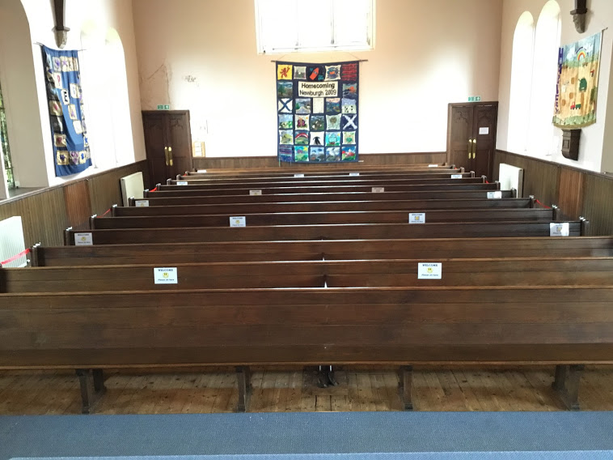Twelve central pews have been removed from Newburgh Church as the narrow space between the rows was considered a health and safety risk during the pandemic. A group of strong volunteers transported the pews to a nearby barn, where they will remain stored pending a future decision about their reinstatement or sale.

Paul Duncan and Robert Neilson spent three days sanding the floor clean of more than a century of ground-in dirt and heel marks. The resulting pale, pitch pine was sealed with a honey-tinted hard wax oil and covered with a non-slip coating.

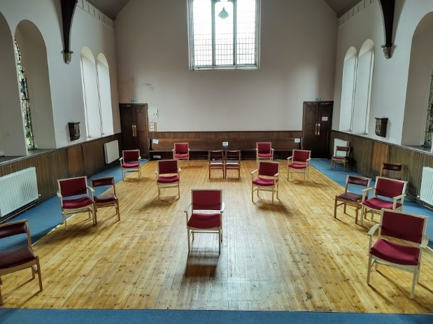We purchased ten comfortable chairs with arms and wine red seats to match the existing choir chairs. This photo shows the seating arrangement for a Sunday service with the statutory 2m distance between chairs or family groups. The side and back pews are also available for those who prefer the original seating.

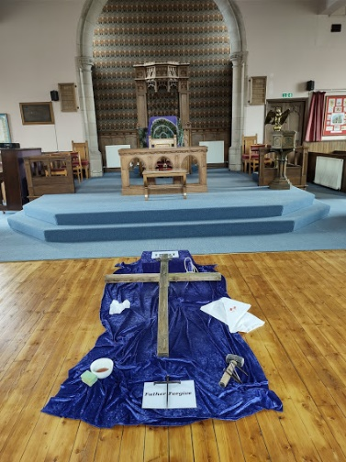

The removable seating allows for a more flexible use of the church for social events and community use as well as for worship. Here’s a display we set up on Good Friday to help people contemplate whilst listening to Passiontide music.

There are more photos about how we managed the pew removal on the website. You’ll find these in the photo gallery section entitled *Newburgh’s Make-Over*

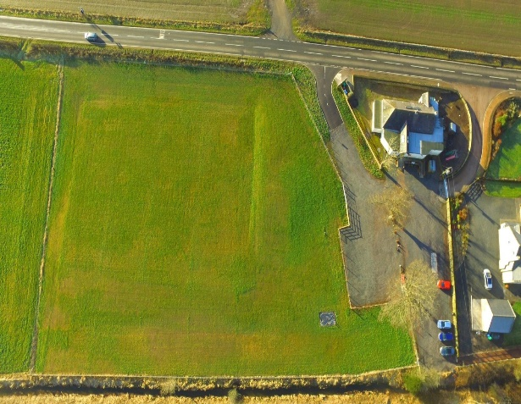 **Dunbog Community Park**

Philip Todd is pleased to announce that the new community park next to Dunbog Community hall and primary school play equipment is almost complete. Philip described his involvement and his impressive commitment to this project to the Abdie congregation last Sunday.

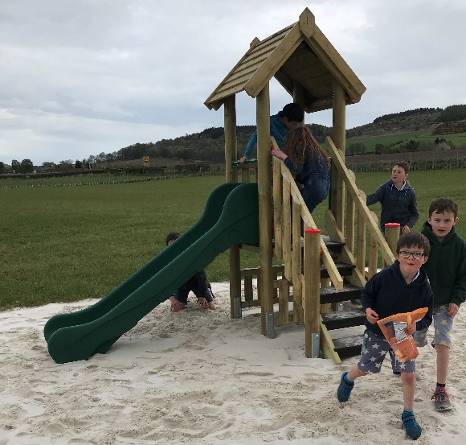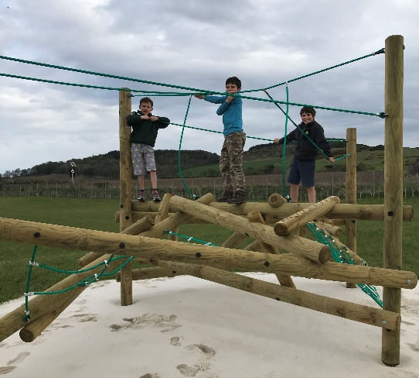An aerial view of the community park shows the new carpark and access road. The field has been levelled to provide a sports field with junior football pitch, running track and long jump. This will provide an excellent facility for the primary school as well as for community events such as the popular Dunbog games.

Philip described his delight at seeing the play equipment installed and watching some of the children of the Community Hall Committee checking it out last week. The community park will be officially opened on Saturday 4th September; we are all invited!

**Easter Day at Abdie**

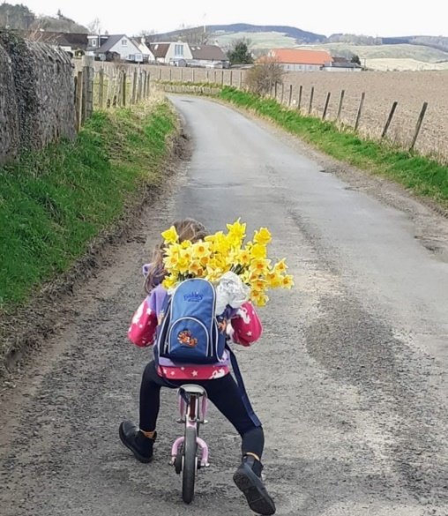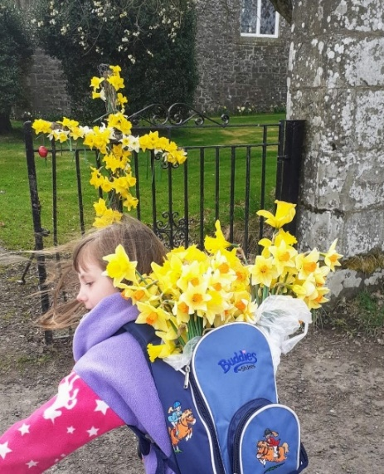Having made a beautiful daffodil cross for us to enjoy on Easter Sunday, one young parishioner was delighted to cycle home with her own rugsack of flowers after the service.

**Newburgh Glebe**

Several people are surprised to learn that our Parish owns 16 acres of glebe land in Newburgh, situated between Monkswell Road and Susie’s plantation. It’s accessible on foot via a kissing gate and a climbing footpath, shortly after Anderson Street, and the views from the top are superb. We are currently considering how some, or all, of this land might be better used to benefit our community as well as responding to a key mark of the Church’s mission i.e. “*To safeguard the integrity of creation and to sustain and renew the life of the earth”* .

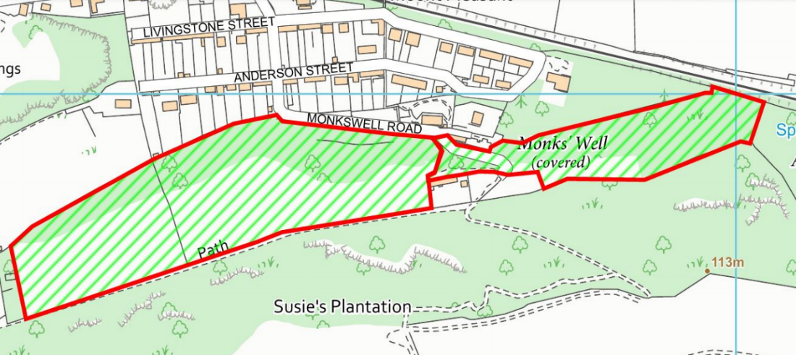Possible options for increased biodiversity & carbon capture include planting more woodland and developing new wildflower meadows. Some areas could be used for education, recreation and exercise.  Newburgh primary school are keen to use of the glebe for outdoor learning and a variety of activities. We would welcome any other ideas too

**Contemplative Garden Corner**

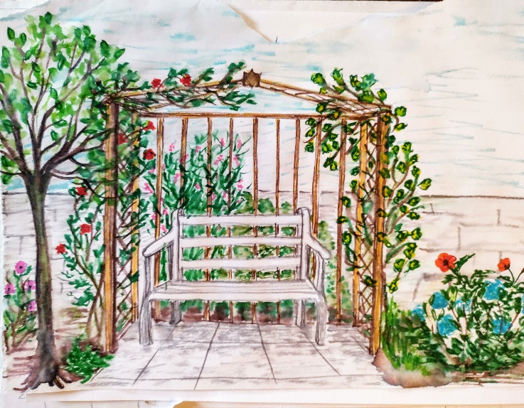When some parishioners expressed a desire for a peaceful place to sit in the church garden Clare Doig came up with this drawing. Session have now given permission for Clare & Gordon to build and plant this contemplative corner in the back garden at Newburgh church.

If anyone wishes to donate items to assist this project Clare will need: A small, beautiful tree, a wooden bench (approx 4’6”), Trellis (6’ x 3’), 4 wooden posts (7’x 3”) & paving slabs. Please contact Clare if you can provide any of these [Doigs@hotmail.co.uk](mailto:Doigs@hotmail.co.uk)

Donations for the new church chairs would also be welcomed by our treasurer. It could maybe be a gift in memory of someone? Each armchair cost £130 but any amount would be gratefully received. The email of our treasurer, James Leslie-Melville is [lmjc@btinternet.com](mailto:lmjc@btinternet.com)

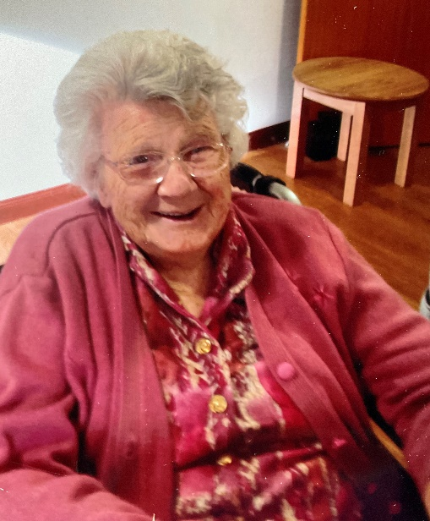  **Farewell** **Alice Thornton: 1919 –2021**

Our oldest church member, aged 101, died peacefully at Strathview Care home on May 13th. The staff cared for Alice extremely well and she never lost her wonderful wit and humour. Alice’s own nursing skills and advice previously benefitted generations of families. Known as someone who held true to what she believed, Alice will be remembered with a smile and great fondness by her community.

**Church service dates**

Please let Valerie know in advance if you would like to attend any of the below services. All our Sunday services are live streamed via Zoom (details on website)

Sunday 16th May – Newburgh 10.30am

Thursday 20th May – Celtic Communion, Newburgh 10.30am

Saturday 22nd May – Crazy Church, Newburgh 3pm

Sunday 23rd May – Abdie 10.30am

Sunday 30th May – Newburgh 10.30am

Sunday 6th June – Abdie 10.30am + baptism

Sunday 13th June – Newburgh 10.30am

Thursday 17th June – Celtic Communion, Abdie 10.30am

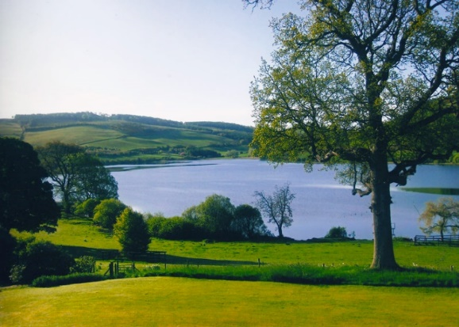 **Sunday May 23rd & July 25th 1-5pm:** Open Gardens Lindores House

There will be a plant stall available for which Elizabeth Turcan would welcome any contributions on Saturday 22nd May - LABELLED if possible. Proceeds will go to Lindores Parish Church

Sadly no refreshments can be provided but visitors are welcome to bring their own picnics and rugs/chairs

Valerie Walker’s contact details:

[revalerian@gmail.com](mailto:revalerian@gmail.com)

phone 01337 842799, mobile 07720 327766